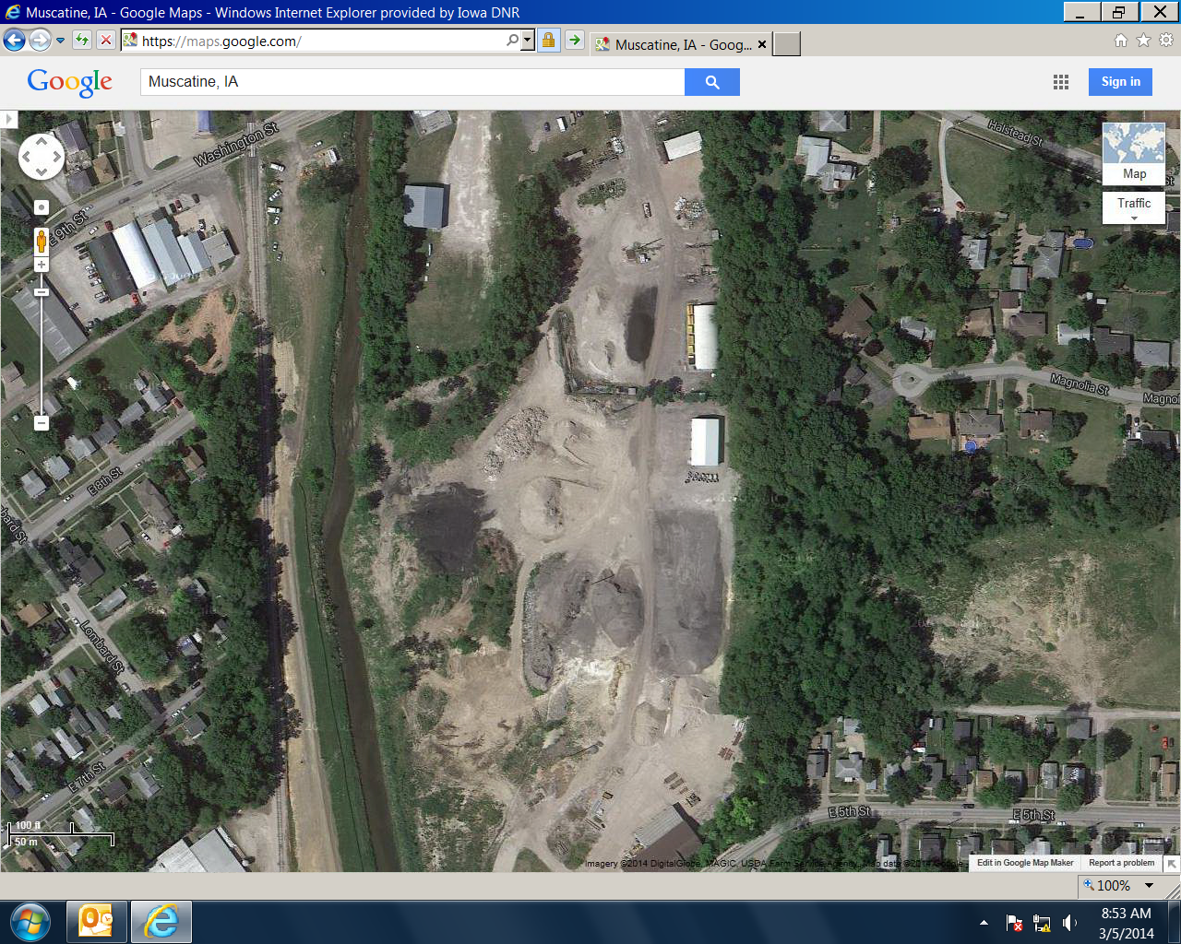
This red line shows the approximate area, along Mad Creek, where a berm had been built to settle solids before stormwater runoff could enter the creek. See attached photos of this burm.
This photo was taken May 2012
These piles were and still are ground up asphalt piles….NOT BOTTOM ASH.
Bottom ash pile. The pile as observed yesterday was WAY smaller than the stockpile shown in this photo.
Right up here, just off the map, is where the covered building housing the mixed asphalt and salt is located.

