The Woodbine Finishers confinement facility in Harrison County has been working on the repairs of their liner because there were areas where the liner was bubbling to the surface. They have completed the repairs and this is the lowest I've ever seen the liquid levels, which is awesome! However, when I followed up the liner isn't really 'tight', I'm not sure how to explain it, but the photos below will hopefully help. My question, do you know, when the liners look like this, is it okay or should it be tight or doesn't it matter? Thanks!

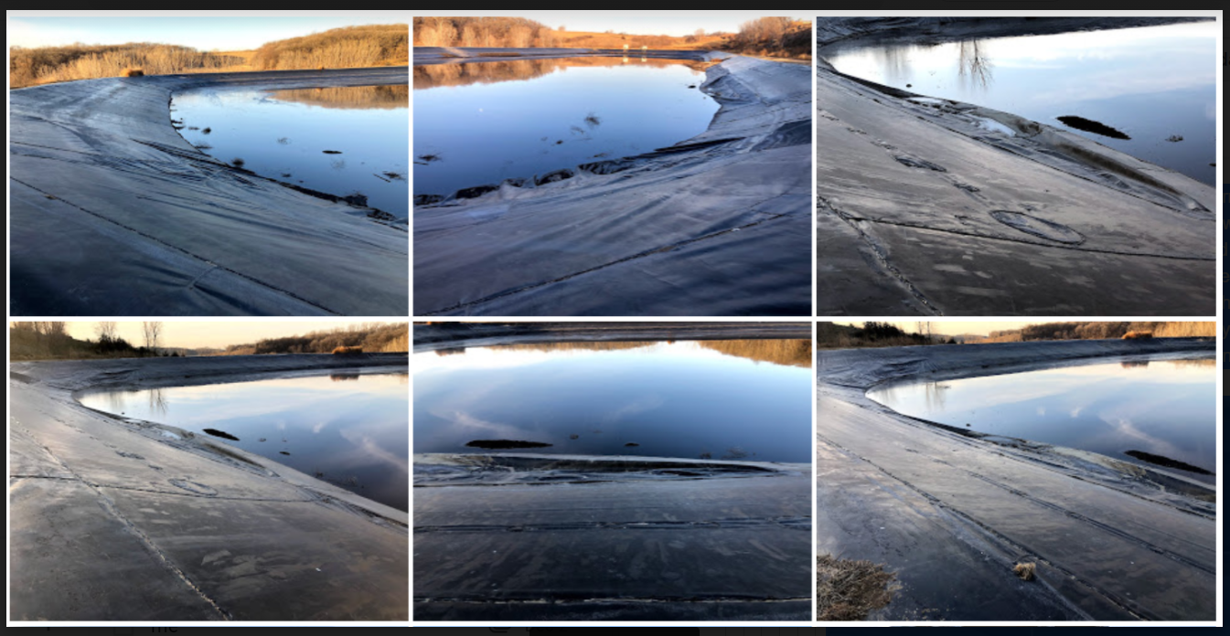

Paul’s response: Well it is probably better than it was so maybe see what happens next basin inspection?

