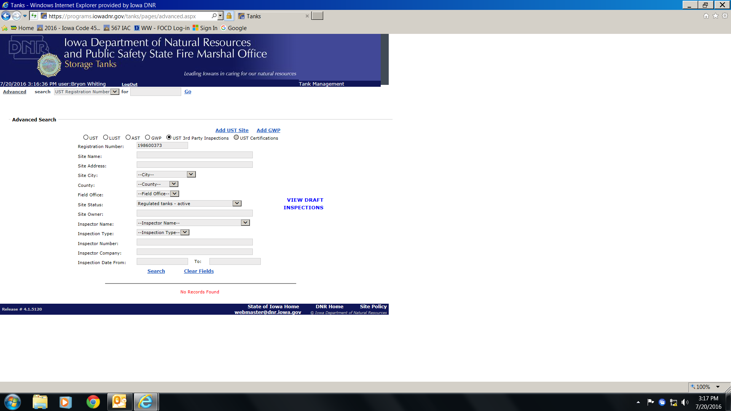

Whiting conducts an audit inspection of the Spencer Municipal Hospital (UST #198600373) on 7-19-2016. Whiting was unable to enter the inspection findings in the tank data base as (evidenced/shown) above as it says there is no record of this facility.
In any event, I found the facility to be in compliance with the UST rules during my 7-19-2016 audit inspection. As such, this copy will be placed into FOCD as evidence of said inspection. BW – 7-20-2016

