Kraft Heinz Mason City - Facility No. 017-01-056
Retification of Deficiencies: EP-SU10 Video Jet Product Code Printing

Records of video jet printing ink usage are kept electronically on a spreadsheet by the Materials Coordinator. The ink currently used at the plant are Video Jet Ink product numbers V-411-D, V4211-D, V706-D, V7206-D, and V901-Q. These inks used in the facility for video jet printing no longer contain a glycol ether ingredient. Therefore, there is no glycol ether HAP calculation needed. The information from the product SDS sheets needed for this emission calculation is the weight of the products (6.672 - 7.172 lbs), 2022 usage (329 gal) and the VOC content (78-97% by weight). I used the middle of the range for weight as well as VOC content in calculation. That information inserted into the VOC Emission calculation comes to 1.002 tons of VOC emissions. The Case Code Ink SDS will be submitted along with this document.
1. 2022 Video Jet Ink Usage:
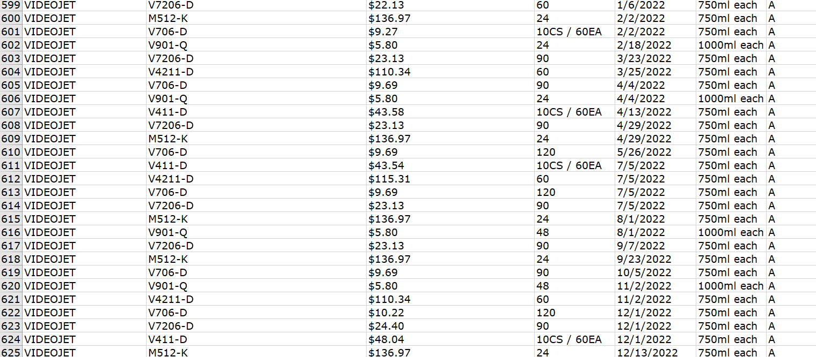
* Video Jet Ink V-411-D is six cartridges per case, 60 per order

