Kraft Heinz Mason City - Facility No. 017-01-056
Rectification of Deficiencies: EP-15 Ink, Solvent, Glue Usage

At the time of the inspection it was determined the EP-15 for our plant was pertaining to the usage of hot melt glues. This was due to EP-SU9 as well as EP-SU10 are in place for all inks used in the plant. Records for the usage of these glues are kept on spreadsheet by the Plant's Material Coordinators. During the inspection the Plant Environmental Coordinator informed the IDNR representative that since the last date of the documentation submitted for EP-15 the plant was using different glues. The SDS sheets for these glues used in 2022 state in Section 15 that the product does not contain any hazardous air pollutants (HAP), as defined by the U.S. Clean Air Act Section 112 (40 CFR 61). The plant is asking for clarification if EP-15, though exempt, is an emission point that needs supporting documentation submitted with the Minor Source Emissions Inventory. Documents are on the following pages.

1. SDS sheets containing Sec. 15 for the three glues used in 2022 and currently (Full SDS sheets will be sent as with this correspondence):

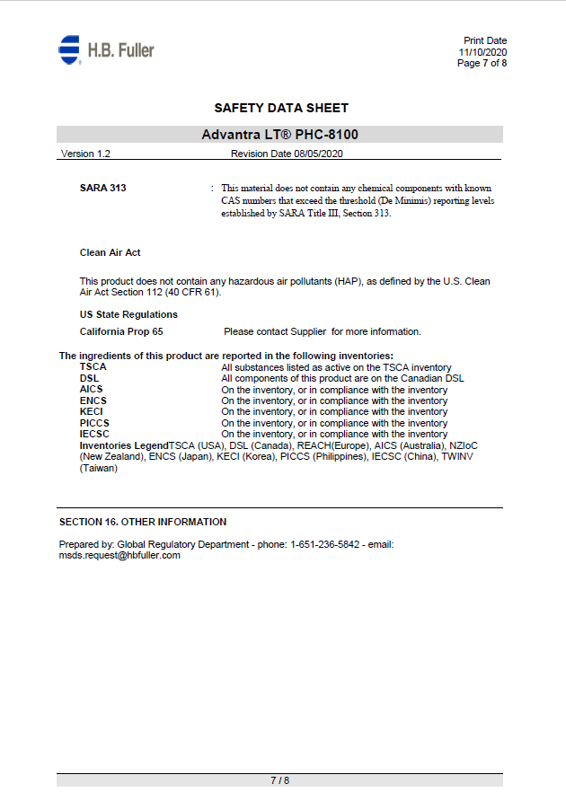
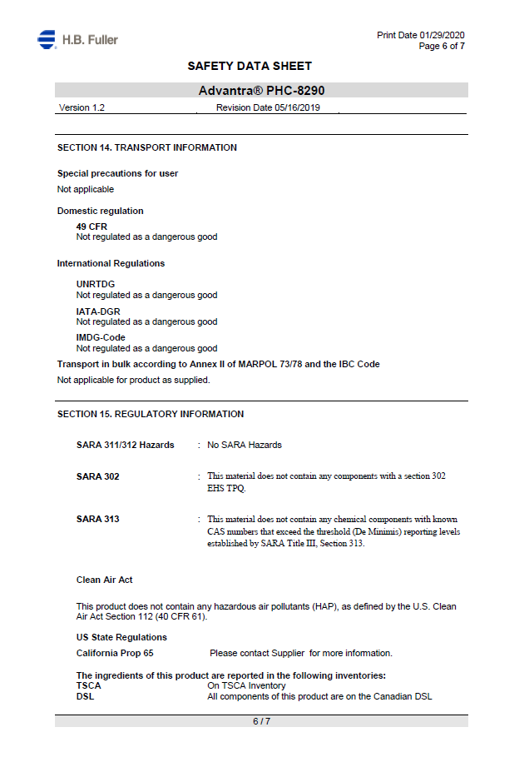
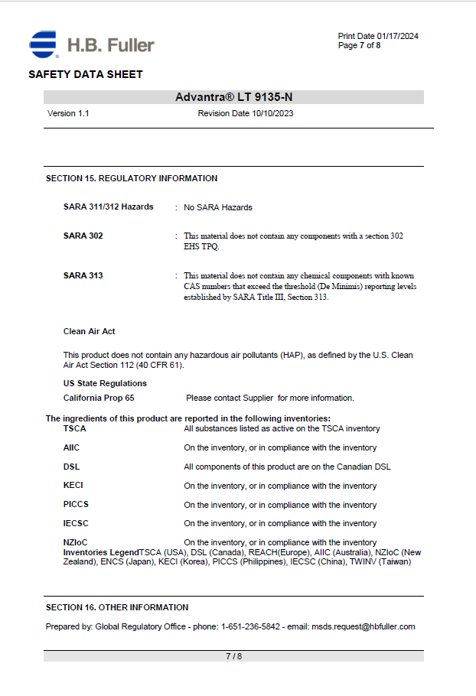

2. Glue Usage Record 2022:

