Kraft Heinz Mason City - Facility No. 017-01-056
Rectification of Deficiencies: EP-1, EP-2, & EP-3 Starch Silos Filling

Records for starch trucks unloading were noted on the Inbound/Outbound Truck Access Log sheets log kept by the Plant Materials Manager. One of the plant's action from the inspection beginning in 2024 the Plant's Materials Manager will maintain and keep these logs electronically to ensure better access for future inspections and audits. Additionally, starch order receiving records are maintained electronically in the company's SAP software business management system. That is another record keeping source of the amount of starch filling of the emission point silos. Access to this information will now be able to be sourced by more individuals in the plant for future inspections and audits.

1. Inbound & Outbound Truck Logs with for starch deliveries in December of 2023:

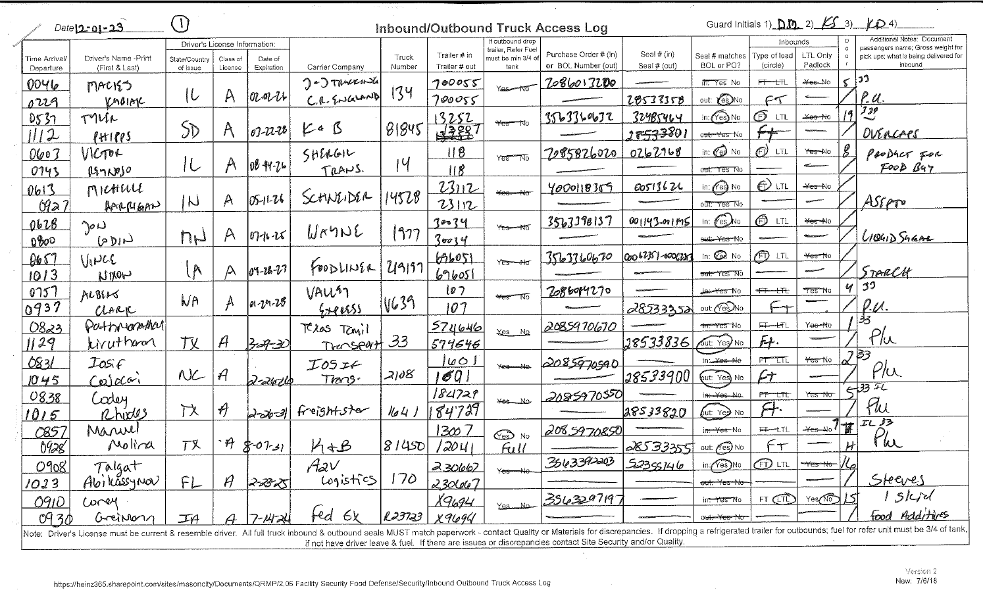
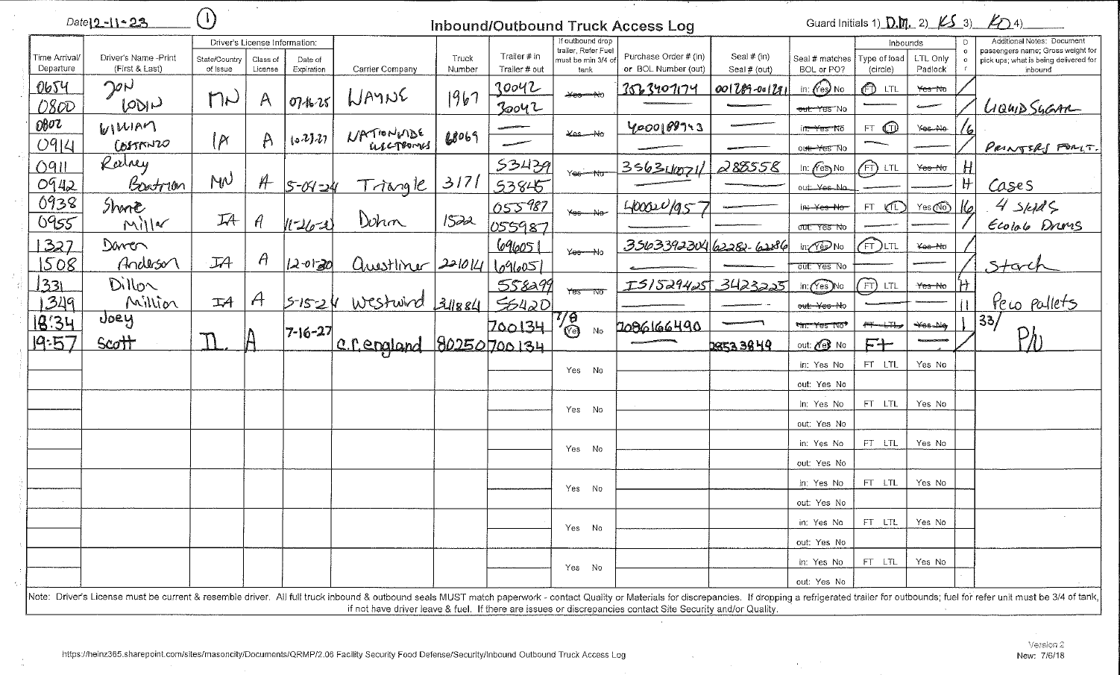
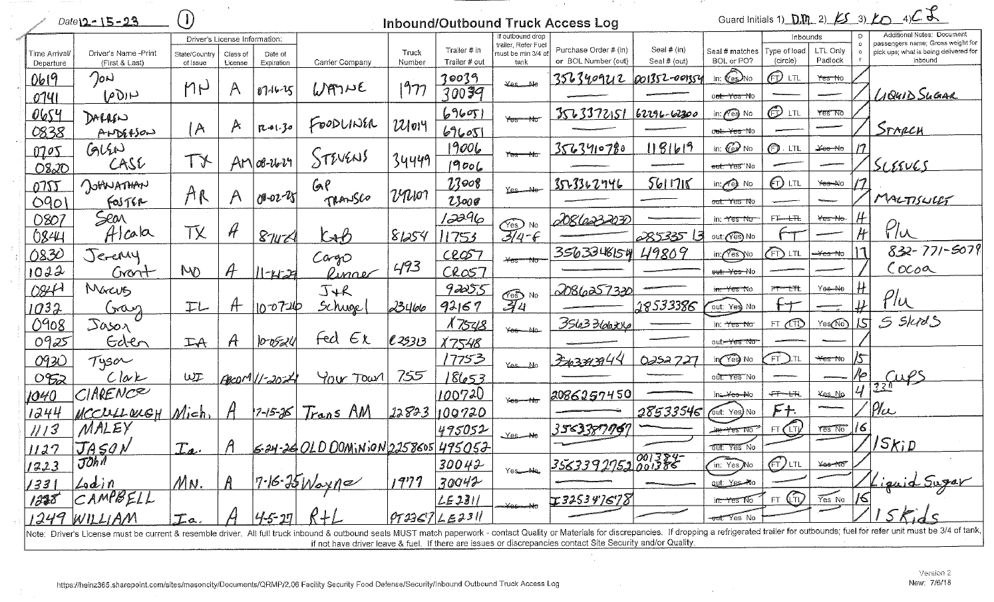
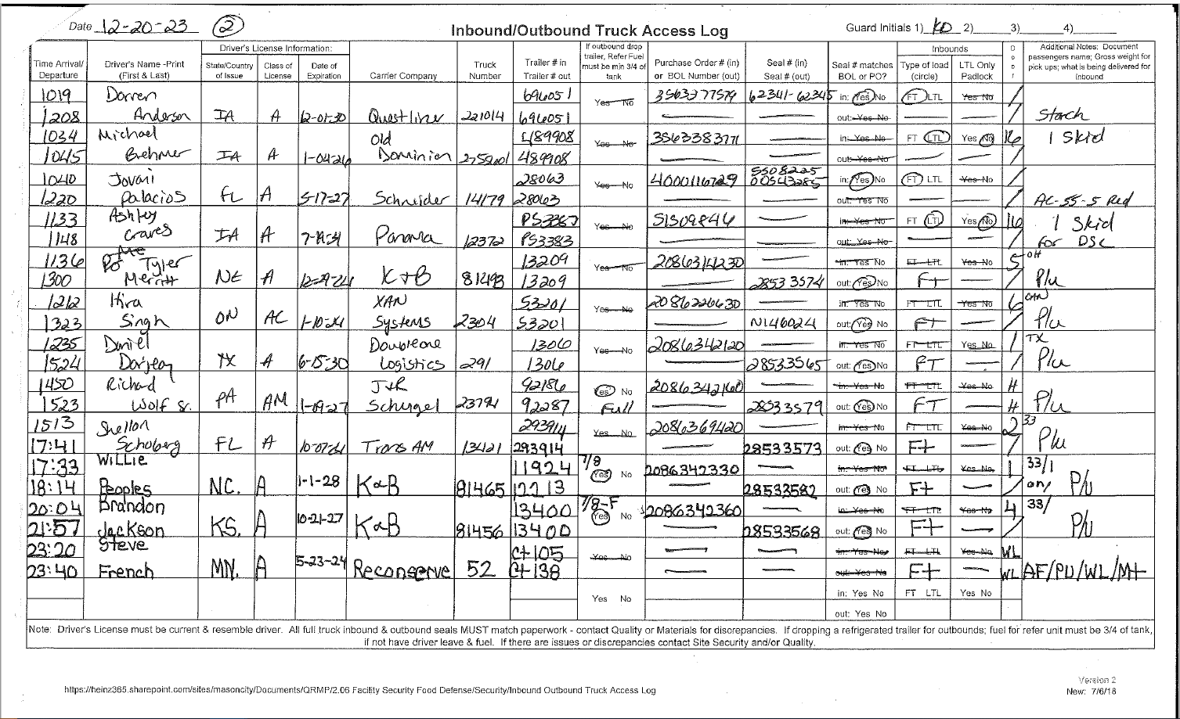
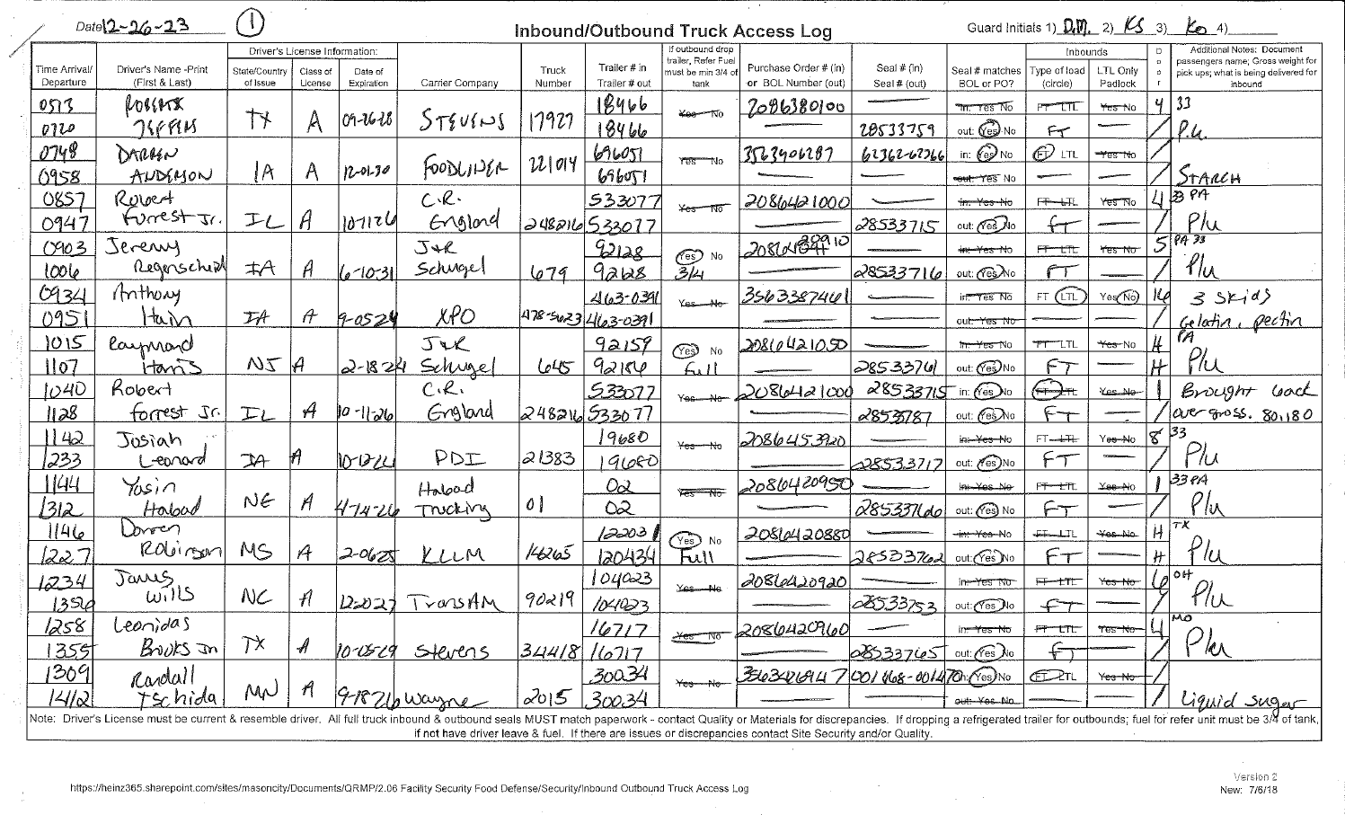

2. Starch Unloading Spreadsheet December 2023:
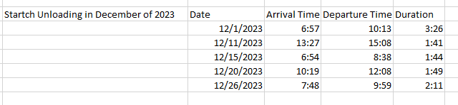

3. December Starch Orders in December of 2023

