November 15, 2023

VINCE TESSANDORI BUSINESS UNIT LEADER
IOWA CAGE FREE
13780 450TH STREET
THOMPSON IA 50478

Subject: Notice of Violation – General Water Quality Criteria & Storm Water
Wastewater Treatment Facility Inspection
Permit No. 9500102

Dear Mr. Tessandori,

Carl Berg, Environmental Specialist with this office, conducted an inspection of your facility on October 26, 2023. A field inspection report was completed and is enclosed for your file. I concur with the content of the report.

At the end of this report, Mr. Berg has summarized his recommendations for facility operation improvements and stated required actions that must be completed in order to comply with the Iowa Administrative Code. Failure to comply can result in referral to the Department’s Legal Services Section for consideration of enforcement action.

If you have any questions concerning the report, please contact Mr. Berg at 641-424-4073 or carl.berg@dnr.iowa.gov.

Sincerely,

FIELD SERVICES & COMPLIANCE BUREAU

Trent Lambert
Field Office Supervisor

TL/cb

Enclosure

c: Greg Kemnitz, gkemnitz@iowacagefree.com

Iowa Department of Natural Resources
Wastewater Treatment Facility Inspection Form
NPDES Permit #: |  | 9500102 |  |  |  |  |  |  |  |  |  |  |  |  |  |  |  | Page 1

FACILITY INFORMATION
Facility: | Name: |  |  |  |  | Iowa Cage Free |  |  |  |  |  |  |  |  |  |  |  |  |  |  |  |  |  |  |  | Plant Grade: |  |  |  |  |  |  |  |  |  |  |  | N/A
 | Responsible Authority/Owner: |  |  |  |  |  |  |  |  |  |  |  |  | Iowa Cage Free LLLP
 | Address: |  |  |  |  |  |  | 13780 450th Street |  |  |  |  |  |  |  |  |  |  |  |  |  |  |  |  |  |  |  |  |  | Phone: |  |  |  |  | 641-584-2050
 | City: |  |  | Thompson |  |  |  |  |  |  |  |  |  |  |  |  |  |  | State: |  |  |  | IA |  |  |  |  |  |  |  |  |  |  |  |  | Zip: |  |  |  | 50478
Responsible Operator: | Name: |  |  |  |  | Greg Kemnitz |  |  |  |  |  |  |  |  |  |  |  |  | Grade: |  |  |  | WW-II |  |  |  |  | Certification Number: |  |  |  |  |  |  |  |  |  |  | 6171
General Description: | This is an industrial wastewater treatment facility designed to treat wastewater from egg breaking. Treatment is provided by a 4-cell covered aerobic lagoon, two trickling filters and two final clarifiers. Ferric chloride is added prior to the clarifiers for phosphorus removal. The 4 cells are divided into two trains of two cells each with flexibility to isolate any of the cells for repair and maintenance. The lagoons hold a total of 15 million gallons of wastewater. Sludge from the final clarifiers flows by gravity back to the lift station and is pumped to the two primary cells.
Design Capacity: | Average MGD: |  |  |  |  |  |  |  | 0.150 |  |  |  |  |  |  |  |  |  |  |  | Maximum MGD: |  |  |  |  |  |  |  |  |  |  | 0.175
Design Capacity: | Pounds BOD/Day: |  |  |  |  |  |  |  |  |  | 5,000 |  |  |  |  |  |  |  |  |  | PE (BOD): |  |  |  |  |  | 29,412
Now Treating: | Average MGD: |  |  |  |  |  |  |  | 0.054 |  |  |  |  |  |  |  |  |  |  |  | Maximum MGD: |  |  |  |  |  |  |  |  |  |  | 0.0912
 | Pounds BOD/Day: |  |  |  |  |  |  |  |  |  | 1004 |  |  |  |  |  |  |  |  |  | PE (BOD): |  |  |  |  |  | 5906
 | Period Reviewed: |  |  |  |  |  |  |  |  | June 2018- September 2023 |  |  |  |  |  |  |  |  |  | Population Served: |  |  |  |  |  |  |  |  |  |  |  |  |  | N/A
Receiving Stream: |  |  | Drainage Ditch #18, tributary to Pike Run, tributary to the Winnebago River

INSPECTION INFORMATION
Inspection: | Date and Time of Inspection: |  |  |  |  |  |  |  |  |  |  |  | October 26, 2023 1pm |  |  |  |  |  |  |  |  |  | Purpose: |  |  |  |  |  | Compliance Evaluation Inspection
 | Date of Last Inspection: |  |  |  |  |  |  |  |  |  |  | July 17, 2018
Persons Interviewed: | Name: |  |  |  |  |  | Greg Kemnitz |  |  |  |  |  |  |  |  |  |  |  |  |  |  |  | Title: |  | Maintenance Manager
 | Name: |  |  |  |  |  |  |  |  |  |  |  |  |  |  |  |  |  |  |  |  |  | Title:
NPDES PERMIT COMPLIANCE SUMMARY
Self-Monitoring: | Operation Reports Submitted:  Sat. Marg.* Unsat.* |  |  |  |  |  |  |  |  |  |  |  |  |  |  | Required Data on Reports:  Sat. Marg.* Unsat.* |  |  |  |  |  |  |  |  |  |  |  |  |  |  | Testing Adequacy:  Sat. Marg.* Unsat.*
Effluent Limitations: | Self-Monitoring Results:  Compliance Infrequent Non-Compliance* Significant Non Compliance*
Samples this Inspection: | Type: |  |  |  | None |  |  |  |  |  |  |  |  |  |  | Lab Data Attached? Yes No |  |  |  |  |  |  |  |  |  |  |  |  |  |  | Results:  Sat. Marg.* Unsat.*
 | Visual Appearance of Effluent: |  |  |  |  |  |  |  |  |  |  |  |  |  | Clear with slight tint from ferric chloride
 | Visual Appearance of Receiving Stream: |  |  |  |  |  |  |  |  |  |  |  |  |  |  |  |  | Low flow
Compliance Schedule: | Compliance w/Schedule:  Sat. Marg.* Unsat.* NA |  |  |  |  |  |  |  |  |  |  |  |  |  |  |  | Next Item Due: |  |  |  |  |  |  | Submit One Year of Phosphorus Data
* Additional details in the narrative report |  |  |  |  |  |  |  |  |  |  |  |  |  |  |  |  | Date Due: |  |  |  |  |  |  | February 1, 2024
AUTHENTICATION
Inspector: | Carl Berg |  |  |  |  |  |  |  |  |  |  |  |  |  |  |  |  |  |  |  |  |  |  |  |  |  |  |  |  |  |  |  | Date:
Reviewer: | Sheila Bly 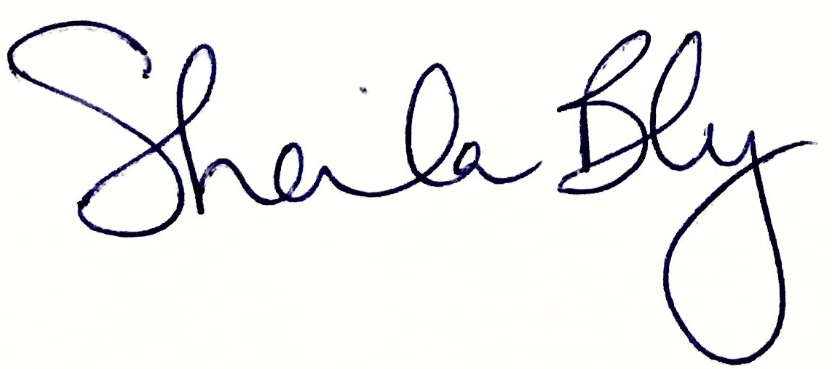 |  |  |  |  |  |  |  |  |  |  |  |  |  |  |  |  |  |  |  |  |  |  |  |  |  |  |  |  |  |  |  | Date: |  |  |  | 11/13/2023

Iowa Department of Natural Resources
Wastewater Treatment Facility Inspection Form
NPDES Permit #: |  |  | 9500102 |  |  | Page 2

FACILITY EVALUATION
Were deficiencies noted or significant observations made during the inspection?
 |  | Yes = See Comments Section for details
 |  | No = No deficiencies or significant observations were noted
 |  | Lack of Entry = Item not applicable or not observed.
Item |  |  |  | Yes | No | Item |  | Yes | No
1. Collection System |  |  |  |  |  | 9. Sludge Handling and Disposal
 | a. Operation and Maintenance |  |  |  |  |  | a. Operation and Maintenance
 | b. Physical Condition |  |  |  |  |  | b. Physical Condition
 | c. Dry Weather Capacity |  |  |  |  |  | c. Capacity
 | d. Infiltration/Inflow |  |  |  |  |  | d. Effectiveness
 | e. Bypass(es) |  |  |  |  |  | e. Final Disposal, Solids
2. Lift Station(s) (Collection System) |  |  |  |  |  |  | f. Final Disposal, Liquids
 | a. Operation and Maintenance |  |  |  |  | 10. Lagoon Structures
 | b. Physical Condition |  |  |  |  |  | a. Maintenance
 | c. Capacity |  |  |  |  |  | b. Physical Condition
 | d. Reliability/Emergency Operation |  |  |  |  |  | c. Capacity
3. Industrial Waste Pre-Treatment |  |  |  |  |  |  | d. Cell Configuration
 | a. Significant Industrial Users |  |  |  |  |  | e. Storage/Drawdown Management
 | b. Waste Toxicity/ Compatibility |  |  |  |  | 11. Flow Measurement
 | c. Strength Reduction |  |  |  |  |  | a. Operation and Maintenance
 | d. Effect on Treatment Plant |  |  |  |  |  | b. Capacity
4. Preliminary Treatment |  |  |  |  |  |  | c. Continuity
 | a. Operation and Maintenance |  |  |  |  |  | d. Location. Method/ Effectiveness
 | b. Physical Condition |  |  |  |  | 12. Pumping
 | c. Capacity |  |  |  |  |  | a. Operation and Maintenance
 | d. Effectiveness |  |  |  |  |  | b. Physical Condition
5. Primary Treatment |  |  |  |  |  |  | c. Capacity
 | a. Operation and Maintenance |  |  |  |  |  | d. Reliability/ Emergency Operation
 | b. Physical Condition |  |  |  |  | 13. Miscellaneous
 | c. Capacity |  |  |  |  |  | a. Location
 | d. Sludge/Scum Removal |  |  |  |  |  | b. Odors
 | e. Effectiveness |  |  |  |  |  | c. Emergency Operation
6. Secondary Treatment |  |  |  |  |  |  | d. Bypass(es)
 | a. Operation and Maintenance |  |  |  |  |  | e. Equipment
 | b. Physical Condition |  |  |  |  |  | f. Buildings & Grounds
 | c. Capacity |  |  |  |  |  | g. Lab Certification
 | d. Recirculation |  |  |  |  |  | h. Other (Outfall 001)
 | e. Freezing |  |  |  |  | 14. Staffing, Operator Certification
 | f. Effectiveness |  |  |  |  |  | a. Operator, Direct Responsibility
7. Final Settling |  |  |  |  |  |  | b. Shift Operator(s)
 | a. Operation and Maintenance |  |  |  |  |  | c. General Staffing
 | b. Physical Condition |  |  |  |  | 15. Supplementary
 | c. Capacity |  |  |  |  |  | a. Permit Availability
 | d. Effectiveness |  |  |  |  |  | b. Operation Reports Availability
8. Supplementary Treatment |  |  |  |  |  |  | c. Equipment Records Maintenance
 | a. Operation and Maintenance |  |  |  |  |  | d. Previously Noted Deficiencies
 | b. Physical Condition |  |  |  |  |  | e. Improvements
 | c. Capacity |  |  |  |  |  | f. Domestic/Industrial Growth
 | d. Effectiveness |  |  |  |  |  | g. Recommendations
 |  |  |  |  |  |  | h. Required Actions

Iowa Department of Natural Resources
Wastewater Treatment Facility Inspection Form
Facility Name: | Iowa Cage Free/Ovation |  | Page 3
NPDES Permit #: |  | 9500102 | Inspection Date: | October 26, 2023

INTRODUCTION

A compliance evaluation inspection was conducted at the Iowa Cage Free Thompson wastewater treatment facility. The inspection involved a physical inspection of the wastewater treatment facility, a review of the discharge monitoring reports (DMRs), and a review of company records. The purpose of the inspection was to determine the compliance status of the facility.

NPDES PERMIT COMPLIANCE SUMMARY

NPDES Permit No. 9500102 was issued September 1, 2013, and expired on August 31, 2018. A permit renewal application was received on March 16, 2018. The permit was amended on July 1, 2016, to remove the Nutrient Reduction Requirements page and to add an annual average mass limit for total nitrogen. The amendment also included a construction schedule for the facility to install chemical phosphorus removal to meet the goals of Iowa’s Nutrient Reduction Strategy. The permit was amended on July 3, 2018, to extend the final date of the chloride compliance schedule due to delays caused by the avian influenza outbreak. Continue to operate under the expired permit until a new permit issued.

I reviewed the DMRs for the period June 2018 through August 2023. There were ten violations identified in the attached effluent limit violation report. Seven of the ten violations occurred in 2019 and were ammonia, TSS, or pH limit violations. The most recent TSS daily maximum limit violation that occurred in August 2022 was reported to be a data entry error. A copy of the violation report was provided to Mr. Kemnitz. Any DMRs that are suspected to have a data entry error should be revised and resubmitted with an explanation of why the DMR is being resubmitted.

The permit requires quarterly monitoring of two tile outlets, Outfall 002 and 003, of the lagoon groundwater lowering system. Mr. Kemnitz reported that these outfalls are checked regularly. No discharges were documented during the review period.

Compliance Schedule

A reverse osmosis (RO) water system was installed to reduce chloride in the facility wastewater. The RO system was brought online January 25, 2022. The chloride effluent levels are now well below the effluent limits in the NPDES permit.

Nutrient Reduction Strategy Construction Schedule

The NPEDS permit contains a nutrient reduction strategy construction schedule. A feasibility study was submitted and updated January 8, 2016, for reducing total phosphorus in the final effluent. This strategy has been implemented and the facility is in the final stages of the construction schedule. A ferric chloride feed system was installed in 2022 to reduce total phosphorus concentrations. The facility is currently collecting one year of raw influent and final effluent total phosphorus data. The weekly total phosphorus data collected from January through December 2023 must be submitted to the DNR Field Office and NPDES permit writer by February 1, 2024.

Iowa Department of Natural Resources
Wastewater Treatment Facility Inspection Form
Facility Name: | Iowa Cage Free/Ovation |  | Page 4
NPDES Permit #: |  | 9500102 | Inspection Date: | October 26, 2023

FACILITY EVALUATION

Items 2b, d – Lift Station

The lift station was observed; no problems were noted. The lift station is equipped with an autodialer and an alarm system that notifies staff of problems with the lift station operation. The lift station also is connected to a generator in case of an outage.

Item 9f – Sludge Disposal

Approximately 415,078 gallons of sludge was land applied in 2019 to 168 acres. Portions of the land application records and lab analysis were reviewed. The land application appears to be in compliance with Chapter 121 of the Iowa Administrative Code.

Item 10b – Lagoon Maintenance

The lagoon berms were in good condition. The lagoon covers are periodically damaged by wind and are repaired or replaced as needed. Mr. Kemnitz stated that they are looking at replacing one of the cells with a different style cover that would be more resilient to the wind. It is likely that a construction permit will be necessary for the replacement. Please work with the DNR Wastewater Engineering Section on permitting specifics prior to the replacement.

Item 11a – Flow Measurement

Effluent flow is measured with a Parshall flume and sonic head transducer. Influent flows are measured and calculated based on water use meters in the production facility. A Parshall flume was installed for influent flow measurement but it often is not representative due to egg shell accumulation in and around the flume throat. Please evaluate the influent flow measurements to ensure representative flows are being reported as required.

Item 13c – Emergency Operation

The facility has generators on site that can operate the plant and lift station in the event of a power outage.

Item 13e – Equipment

Isco automated samplers are used to collect the 24-hour composite samples for influent and effluent wastewater. The refrigerators were functional with thermometers inside to demonstrate adequate cooling.

Iowa Department of Natural Resources
Wastewater Treatment Facility Inspection Form
Facility Name: | Iowa Cage Free/Ovation |  | Page 5
NPDES Permit #: |  | 9500102 | Inspection Date: | October 26, 2023

Item 13f – Buildings and Grounds

Prior to and during the inspection, the area received significant rainfall. The facility is undergoing construction to install new poultry confinement buildings and has a stormwater general permit #2. Runoff from various parts of the property were observed with limited or ineffective stormwater controls. A discharge of turbid stormwater was observed to Drainage Ditch #18 downstream of the wastewater outfall. A photo is provided below. Action must be taken to ensure adequate stormwater controls and site maintenance to prevent the discharge of sediment from the site. The turbid water discharge is a violation of the general water quality criteria as described in Subrule 567 IAC 61.3(2). A stormwater inspection will be conducted in the future to evaluate compliance with stormwater requirements.

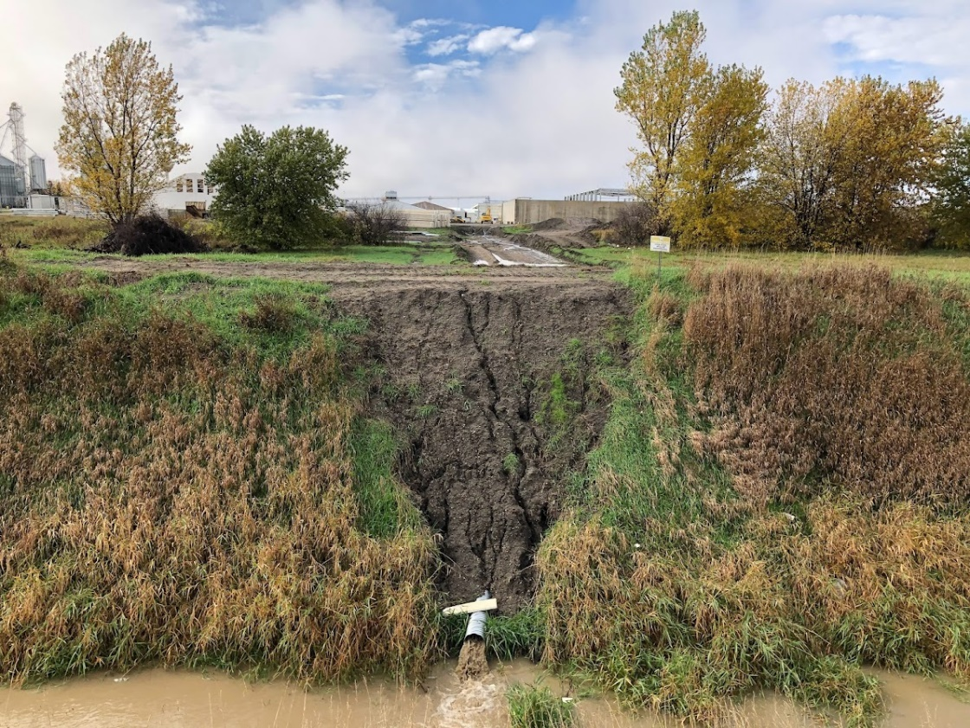
Photo 1. Looking west towards Iowa Cage Free from 130th Avenue

Item 13g – Laboratory Certification

Analytical testing is completed by Test America, which is certified in the State of Iowa for wastewater testing. For quality assurance purposes, effluent total suspended solids and COD are routinely measured on site. Dissolved oxygen and pH testing are also completed on site. Detailed records are being maintained of these onsite monitoring activities. However, when the meters are calibrated these activities were not being recorded and documented. Please document the calibration activities and maintenance when conducted in accordance with Subrule 567 IAC 63.1(3).

Iowa Department of Natural Resources
Wastewater Treatment Facility Inspection Form
Facility Name: | Iowa Cage Free/Ovation |  | Page 6
NPDES Permit #: |  | 9500102 | Inspection Date: | October 26, 2023

Item 13h – Other: Outfalls 001, 002, 003

We observed Outfall 001. The effluent had a slight discoloration which Mr. Kemnitz stated was from the ferric chloride addition. He stated that they have not had any orange discoloration as previously documented in 2019 and 2020. It is suspected that those instances of orange discoloration were due to possibly overloading of the wastewater facility and subsequent bacteria growth.

Outfalls 002 and 003 are dewatering tiles around the aerated lagoon. No discharges from these outfalls occurred during the review period to Drainage Ditch #74 located north of the aerated lagoons. There is a large stormwater retention basin immediately to the north of the lagoons to capture stormwater runoff from the construction on the facility grounds. Despite the significant size of the retention basin, the configuration of the drainage appeared to allow the stormwater to pass through the basin. The outfall from the basin was not observed, but it likely was also discharging sediment laden stormwater to Drainage Ditch #74.

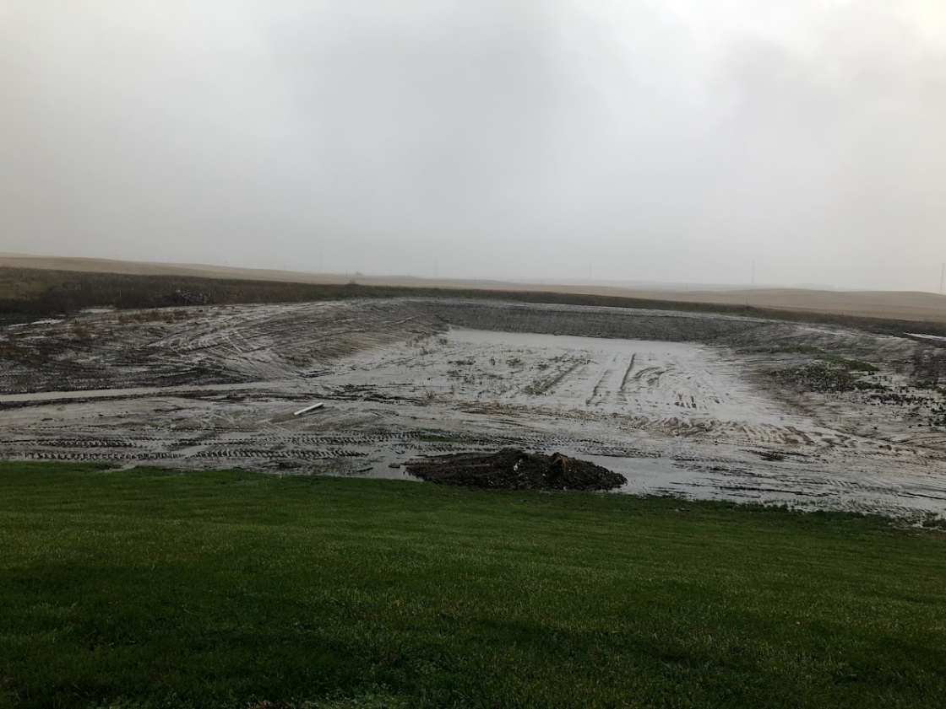
Photo 2. Looking north at stormwater retention basin from aerated lagoon berm.

Iowa Department of Natural Resources
Wastewater Treatment Facility Inspection Form
Facility Name: | Iowa Cage Free/Ovation |  | Page 7
NPDES Permit #: |  | 9500102 | Inspection Date: | October 26, 2023

SUMMARY

The facility is considered to be in infrequent noncompliance with the permit limits. The total phosphorus weekly data from the 2023 calendar year must be submitted by February 1, 2024. During the inspection, stormwater runoff from the facility construction was causing a general water quality violation in the drainage ditch. Additional stormwater controls and measures are necessary to eliminate the illegal discharge of sediment laden stormwater.

REQUIREMENTS

- Comply with all permit limits per Subrule 567 IAC 64.3(1).

- Submit one year of at least weekly total phosphorus sampling data from raw waste and final effluent by February 1, 2024, per Subrule 567 IAC 64.3(1).

- Storm water controls and site maintenance are needed to prevent the discharge of sediment from the site in accordance with stormwater general permit #2 and Subrule 567 IAC 64.3(1).

- Eliminate the discharge of sediment laden water in accordance with Code of Iowa Section 455B.186 and Subrule 567 IAC 61.3(2).

- Evaluate influent flow to ensure data is representative of actual flows to the wastewater treatment facility per Subrule 567 IAC 64.3(1).

- Obtain a construction permit if necessary for the replacement of the lagoon cover(s) per Subrule 567 IAC 64.1(3).

- Document calibration of onsite monitoring equipment in accordance with Subrule 567 IAC 63.1(3).

 | Effluent Limit Violations 6/1/2018 - 11/1/2023
 | REMBRANDT ENTERPRISES, INC. (NOW IOWA CAGE-FREE, L.L.L.P.) - 9500102
 | THOMPSON  EPA #: IA0076252 |  | DAILY MAXIMUM - LBS/DAY |  | AVERAGE - MG/L |  | DAILY MAXIMUM - MG/L |  | DAILY MAXIMUM - STD UNITS |  |  | Parameter  Monthly Total
 |  |  | Limit | DMR | Limit | DMR | Limit | DMR | Limit | DMR
 | Outfall: 001
 | 2/2019 | TSS |  |  | 30 | 30.675 |  |  |  |  |  | 1
 | 3/2019 | NH3-N |  |  |  |  | 2.2 | 3.43 |  |  |  | 1
 | 4/2019 | NH3-N | 3.9 | 6.026919 |  |  | 2.7 | 5.12 |  |  |  | 2
 | 4/2019 | TSS |  |  |  |  | 45 | 59 |  |  |  | 1
 | 9/2019 | PH MINMAX |  |  |  |  |  |  | 9 | 9.11 |  | 1
 | 10/2019 | TSS | 54 | 105.9952951 |  |  |  |  |  |  |  | 1
 | 4/2020 | BOD5 |  |  | 30 | 35.2444444 | 45 | 62.1 |  |  |  | 2
 | 8/2022 | TSS |  |  |  |  | 45 | 87.33 |  |  |  | 1
 | #VALUE! |  |  |  |  |  |  |  |  |  |  | Total: 10
Total Violations: 10

