September 8, 2023

Kevin Hildring
Extended Ag
PO Box 134
Lester, IA 51242

SUBJECT: Open Feedlot Compliance Inspection – Fairview Feeders
Sioux County, Iowa – Facility #62532, NPDES Permit #8462532

Dear Mr. Hildring:

Attached is a copy of the report resulting from the National Pollutant Discharge Elimination System (NPDES) compliance inspection on July 21, 2023. Please contact me if you have any questions or if you feel this report does not represent the conditions at your facility. I can be reached at (712) 363-9041.

Sincerely,

Matt Jefferson, Environmental Specialist
matthew.jefferson@dnr.iowa.gov
Field Service and Compliance Bureau

MJ:lw

enc: NPDES Inspection Report
NMP Inspection form
Open Feedlot Manure Stockpiling Regulations

IOWA DEPARTMENT OF NATURAL RESOURCES
OPEN FEEDLOT NPDES COMPLIANCE INSPECTION

NPDES Permit # IA-8463595 Facility ID #63595

FACILITY | NAME: Fairview Feeders |  |  |  | PERMIT EXPIRATION DATE:  May 31, 2025
 | ADDRESS:  1335 290th Street |  | CITY:  Inwood |  | STATE:  Iowa |  | ZIP:  51240
PERSONS  INTERVIEWED | NAME:  Kevin Hildring |  |  | PHONE:  712-478-4582
RECEIVING  WATERCOURSE | STREAM NAME:  Big Sioux River
INSPECTION DATE | DATE THIS INSPECTION:  July 21, 2023 | DATE LAST INSPECTION:  July 20, 2021 |  |  |  | TIME OF INSPECTION:  10:30 AM
SYSTEM TYPE | System 1 (once per year) System 3 (April/July/Oct.) System 5 (April/May/Oct./Nov.)  System 2 (July/Oct.) System 4 (Each Significant Precip. Event) AT System
ANIMAL INFORMATION | ANIMAL TYPE(S) PERMITTED HEAD CURRENT HEAD  Beef Cattle / Hogs 4,350 cattle / 600 swine 1,619 (combined)

PERMIT COMPLIANCE SUMMARY
SELF-MONITORING | QUARTERLY OPERATION REPORTS SUBMITTED:  Sat. Unsat.* | REQUIRED DATA ON QUARTLERY REPORT:  Sat. Unsat.* | ROUTINE VISUAL INSPECTIONS:  Sat. Unsat.*
 | ANNUAL REPORTS SUBMITTED:  Sat. Unsat.* | REQUIRED DATA ON ANNUAL REPORT:  Sat. Unsat.* | ANNUAL MANURE  SAMPLE TAKEN:  Sat. Unsat.*
 | NMP PUBLIC NOTICE:  Sat. Unsat.* | CURRENT NMP:  Sat. Unsat.* | LAND APPLICATION RECORDS:  Sat. Unsat.*
 | ANIMAL INVENTORY  RECORDS:  Sat. Unsat.* | EQUIPMENT INSPECTION DOCUMENTED  Sat. Unsat.* | DEPTH GAUGE INSTALL & MONITORING:  Sat. Unsat.*
OBSERVATIONS | SOLIDS SETTLING  STRUCTURES:  Sat. Unsat.* | BASIN OR AT  STRUCTURES  Sat. Unsat.* | EVIDENCE OF OVERFLOW:  NO
 | MANURE STOCKPILING  Sat. Unsat.* | MANAGEMENT OF DEAD ANIMALS  Sat. Unsat.* | MANAGEMENT OF CHEMICALS  Sat. Unsat.*
 | SURFACE DRAINAGE IS DIVERTED FROM OPENLOT  Sat. Unsat.* | ANIMALS HAVE NO CONTACT WITH WATERS OF US  Sat. Unsat.* | FEEDSTOCK PROPERLY HANDLED & STORED  Sat. Unsat.*

AUTHENTICATION | INSPECTOR:  Matthew Jefferson | DATE:  9/8/23 | REVIEWER:  Jennifer Christian | DATE:

GENERAL FACILITY DESCRIPTION

Fairview Feeders is located in the SW ¼ of the NW ¼ of section 16, T97, 48W, Settlers Township in Sioux County. All animals at this site are penned and have no contact with waters of the United States. The open lot pens have a capacity of 4,000 beef cattle, 350 head of confinement beef cattle, and 600 head of confinement finishing swine.

Runoff from all of the pens at this facility flows away from the central access road into three long, narrow basins that follow the pens on the down-gradient side. Picket-fence filtration structures are placed as needed to remove solids from effluent before it goes to one of the settling basins. SOFEB #1 or “North SOFEB” is the largest of these, accounting for more than half of the facility’s combined capacity of over 3 million gallons.

Each SOFEB was constructed in a location such that vehicle access is possible as needed for dewatering. Staff gauges are required to provide information on depth, and therefore, filled capacity.
There are both indoor and outdoor storage areas for feedstock at this location, and all storage areas are protected from effluent and stormwater by concrete barriers and engineered relief of the pavement underneath. The outdoor storage areas are located to either side of the access drive, sloping away from the open side. The indoor storage area is located west of the access drive, and is situated in such a way that surface flow will not enter.

SELF MONITORING

The NPDES permit issued to this facility clearly describes all required monitoring for the site as well as all reports that must be submitted to the Iowa DNR. All required information must be saved for a period of no less than 5 years. Quarterly reports must be submitted by January 10th, April 10th, July 10th and October 10th. The precipitation and temperature data recorded on these reports may be from the nearest metropolitan area. As an alternative, you may use on-site gauges for the temperature and precipitation measurements. Annual reports are due no later that January 10th of each year. The permit further requires the annual sampling of both solid and liquid manure from the site. These samples are to be submitted to the Iowa DNR annually.

The permitted capacity for this facility is 4,350 head of beef cattle between the open lots and confinement, and 600 hogs in confinement. On the day of this inspection, Mr. Van Beek reported that there were 1,619 combined head onsite for all lots and confinement.

Routine visual inspections for this site have been completed and recorded.

Current soil samples for all fields in the Nutrient Management Plan (NMP) are contained within the plan. There were no issues with the NMP.

All SOFEBs are easily accessible by vehicle or hose for draining. As a System 3 permit holder, the SOFEB is required to be dewatered in April, July and October. Application records indicate de-watering is occurring as required.

Solids are scraped from the pens as needed. Records indicate all solid manure is applied to fields included in the current NMP at rates consistent with the NMP, or stored briefly for later use.

FACILITY EVALUATION

No discharges of manure have been reported or observed at this site.

The topography at this facility resembles an elongated mound, with the high ground following a ridge through the center, where an access road has been constructed. The open lot pens lay to either side of this high ground on the east side of the site, and to the south of this high gound on the west side, with the cattle confinement to the north of it. The three SOFEBs which catch effluent from the open lots are constructed at the bottom of each section of open lots, where effluent flows downhill toward them directly without need for channelization; on the west side, effluent is channeled through a solids-settling structure. If overflow were to occur, it would enter agricultural fields associated with the facility, though the Big Sioux River is also close-by on the southwest side. The open lots would have met all setback requirements at the time of construction, though it appears that the river’s course has been altered by erosion since then. Kevin Hildring has informed me that the bank of the river nearest the lots has since been engineered to resist further erosion in that area, and the shape of the river in aerial views (narrower where it has deepened to accommodate its volume rather than expanding laterally) confirms this.

On the day of this inspection, the SOFEBs had more than adequate capacity remaining to accept the runoff from a 25year/24 hour rain event. The SOFEBs appear well maintained. Gauges or marks to measure the depth and remaining capacity of each SOFEB were not observed at the time of inspection, though this may simply be from vegetative overgrowth present in such a dry year; the SOFEBs were almost entirely empty. A detailed working knowledge of fluid levels as they relate to capacity is critical to operate this system as designed and remain in compliance with the permit and is therefore strongly recommended. Mr. Van Beek is reminded that the SOFEB is not a device strictly for watering crops, but rather an effluent application device and must be managed as such.

During periods of application, manure may be hauled directly to the field for application or stored onsite. Solid settling structures are scraped as needed. Mortalities are rendered in a timely manner. All chemicals are stored under roof; a building along the main access road from 290th Street.

This facility has not received a notice of violation for 10 years.

REQUIREMENTS AND RECOMMENDATIONS

- Because this is a System 3 facility, the SOFEB must be de-watered 3 times per year, in April, July, and October. SOFEB is considered de-watered when effluent remaining in the SOFEB occupies 90% or less of the total capacity. If fluid levels are below this level at the required dates, please indicate this in your record-keeping for these months.

- Maintain all records, including inventory records, for a minimum of 5 years and make them available to the DNR upon request.

- Ensure that staff gauges with “must pump” left are clearly visible.

- Quarterly reports must be submitted on time.

IOWA DEPARTMENT OF NATURAL RESOURCES
ENVIRONMENTAL SERVICES DIVISION

Field Office #1 Field Office #2 Field Office #3 Field Office #4 Field Office #5 Field Office #6
909 West Main, Ste 4 2300 15th St SW 1900 N. Grand Ave. 1401 Sunnyside Lane 401 SW 7th, Ste 1 1023 W. Madison
Manchester, IA 52057 Mason City, IA 50401 Spencer, IA 51301 Atlantic, IA 50022 Des Moines, IA 50309 Washington, IA 52353
563-927-2640 641-424-4073 712-262-4177 712-243-1934 515-725-0268 319-653-2135

Nutrient Management Plan Compliance Review – Nonsales of Manure
Date of Inspection: July 21, 2023 |  |  | Facility ID#: 62532
Facilty Name: Fairview Feeders |  |  | Person(s) Contacted: Kevin Hildring
Facility Address: 1335 290th Street, Rock Valley |  |  | Phone: 712-478-4582

Facility Owner Information & Address Unchanged? Yes No (Database must be updated)
NMP Contents |  |  |  | Yes | No | N.A.
a. | Calculations to determine land area for application? [65.112(8)a]
b. | Total nitrogen and phosphorus available, credits, application losses? [65.112(8)b]
c. | Optimum crop yield and crop usage rate? [65.112(8)a]
d. | Manure application methods and timing of application? [65.112(8)b]
e. | Location of manure application fields? [65.112(8)b]
f. | Landowner or renter agreements? [65.112(8)c]
g. | Estimate of annual animal production and amount of manure produced? [65.112(8)d]
h. | Does P Index no. generated correspond with P Index no. in plan? [65.112(8)a]
i. | Are Rusle2 Profile Erosion Calculation Records included? [65.112(8)a]
j. | Are proper soil sampling methods being used to calculate P Index? [65.112(10)b]
Records Review |  |  |  | Yes | No | N.A.
k. |  | Copy of the current NMP? [65.112(10)a]
l. |  | Records kept for 5 years (or crop rotation if longer)? [65.112(10)b]
m. |  | Methods of application? [65.112(10)b]
n. |  | Dates when manure was applied? [65.112(10)b]
o. |  | Location of manure application? [65.112(10)b]
p. |  | Number of acres? [65.112(10)b]
q. |  | Actual manure application rate? [65.112(10)b]
r. |  | Statement of Intent for application fields not owned or rented? [65.112(10)b]
Field Observations of Manure Storage/Handling/Application & Animal Disposal |  |  |  | Yes | No | N.A.
s. |  | Manure storage structures appear to be properly operated & maintained? [65.112(e)1]
t. |  | Dead animals disposed of properly [567 IAC 100.4(455B) & Code of Iowa 167.18]?  Type: Compost Incinerator Burial Rendering
Discussion Items: |  |  |  | Yes | No | N.A.
u. |  | Manure release notification made within 6 hours? [65.2(9)a]
v. |  | Deficiencies and violations?
w. |  | Recommendations, improvements, environmental issues?
x. |  | Proper manure application? [65.112(10)]

Comments: All fields owned or rented.

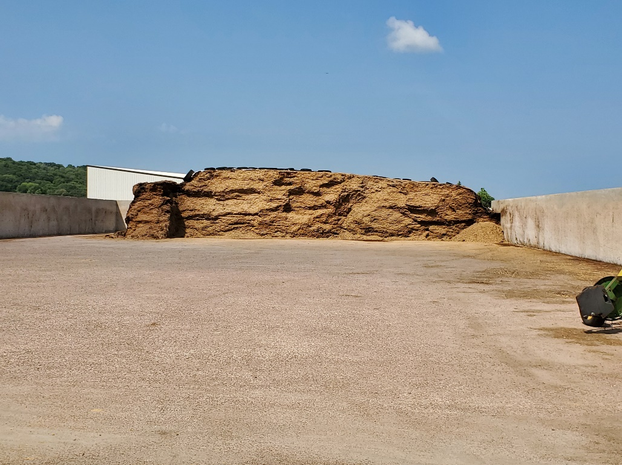 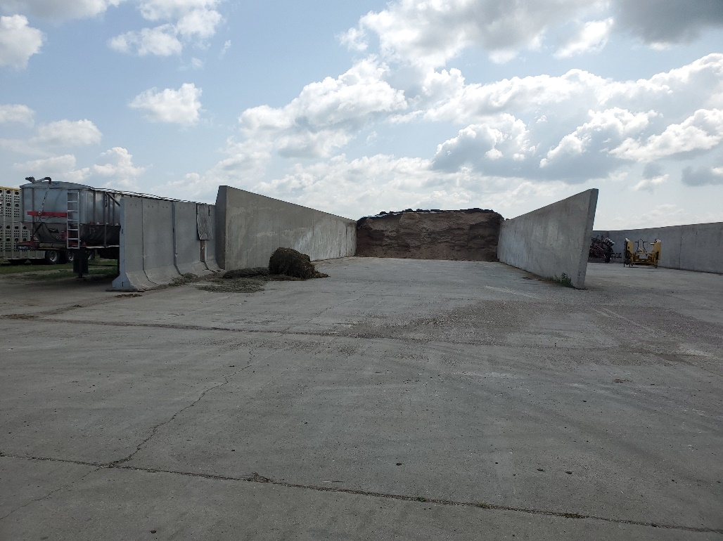 Figure 1: Outdoor feed storage west of access drive – protected from stormwater entering Figure 2: Outdoor feed storage east of access drive – protected from stormwater entering
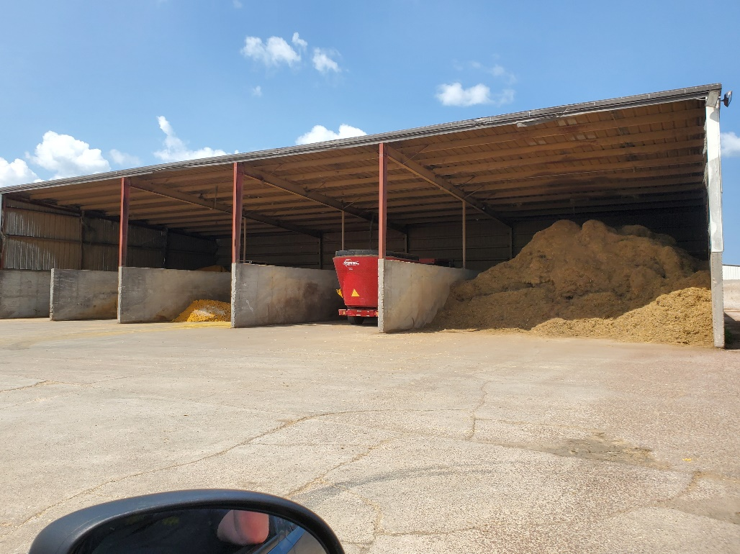 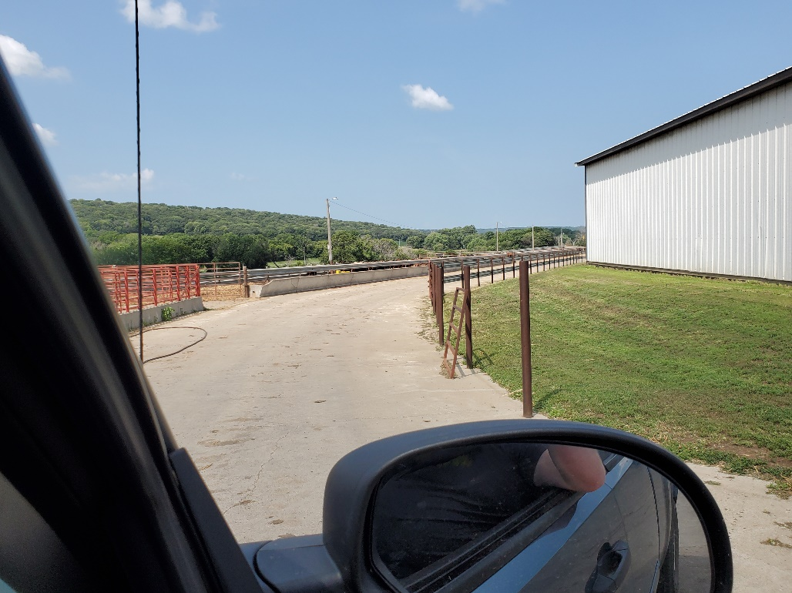Figure 3: Covered feed storage west of access drive – protected from stormwater completely Figure 4: Access drives channel stormwater with concrete feeders doubling as barriers
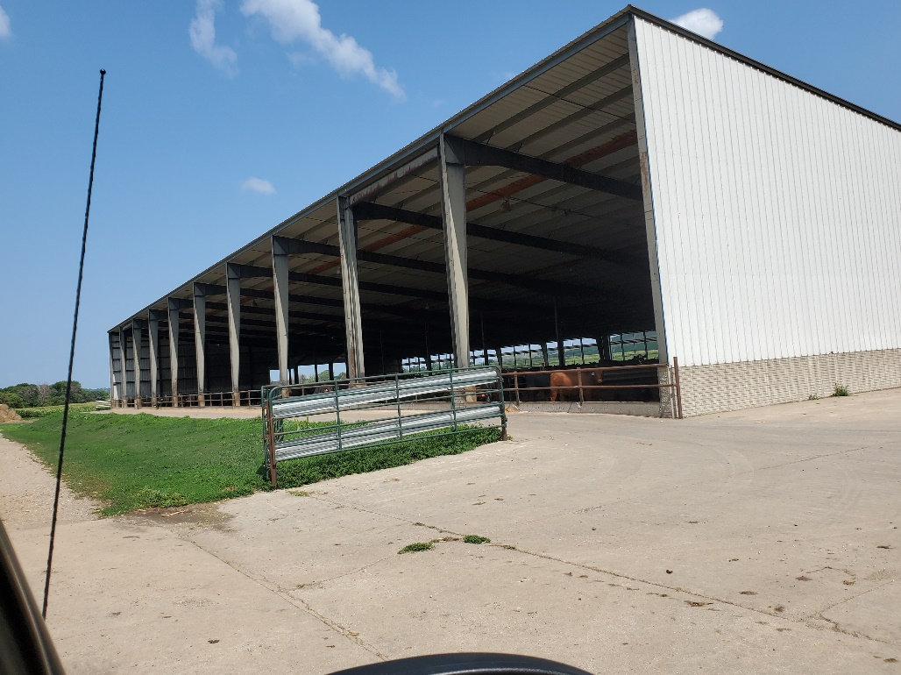 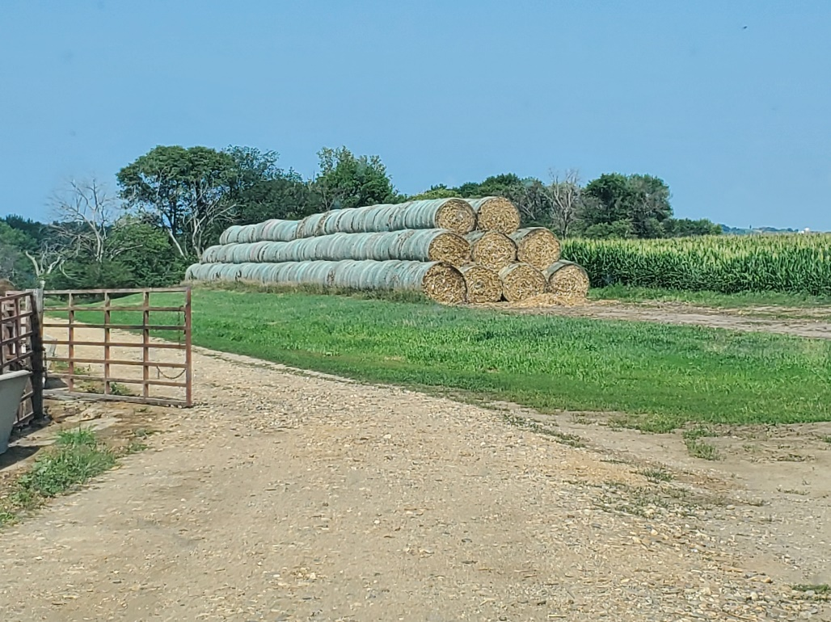Figure 5: Cattle confinement in northwest portion of site Figure 6: Additional feed storage in northwest portion of site, up-gradient from lots
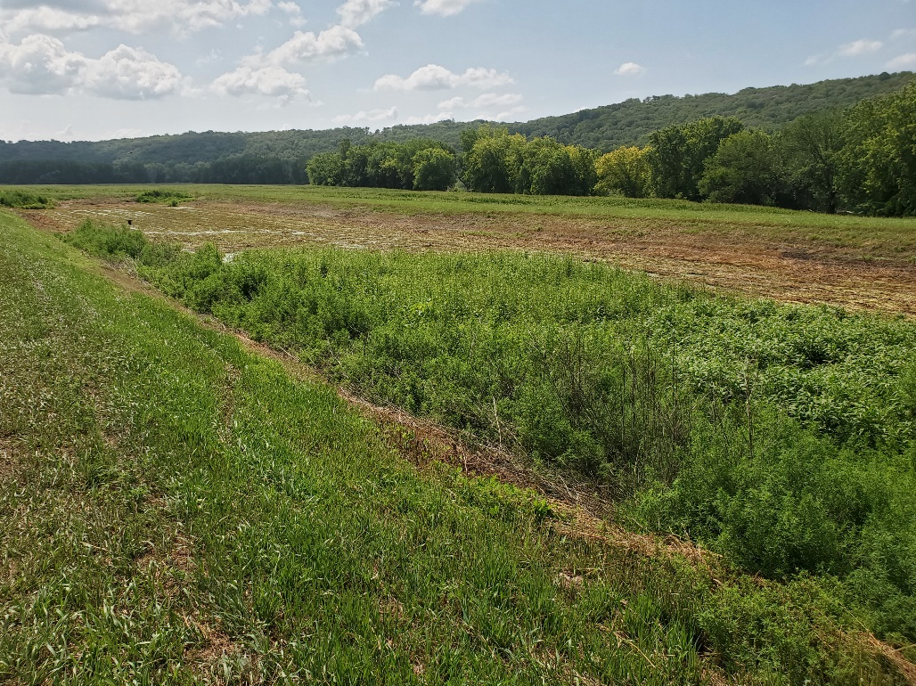 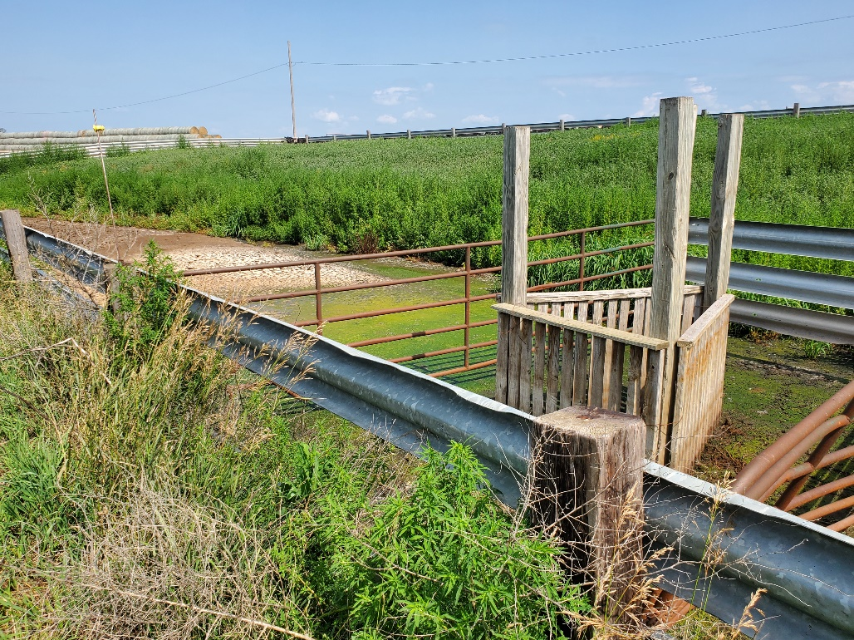Figure 7: SOFEB for western lots is almost completely dry this year – very little rain Figure 8: Picket fence style filter strains solids as effluent leaves western pens for SOFEB
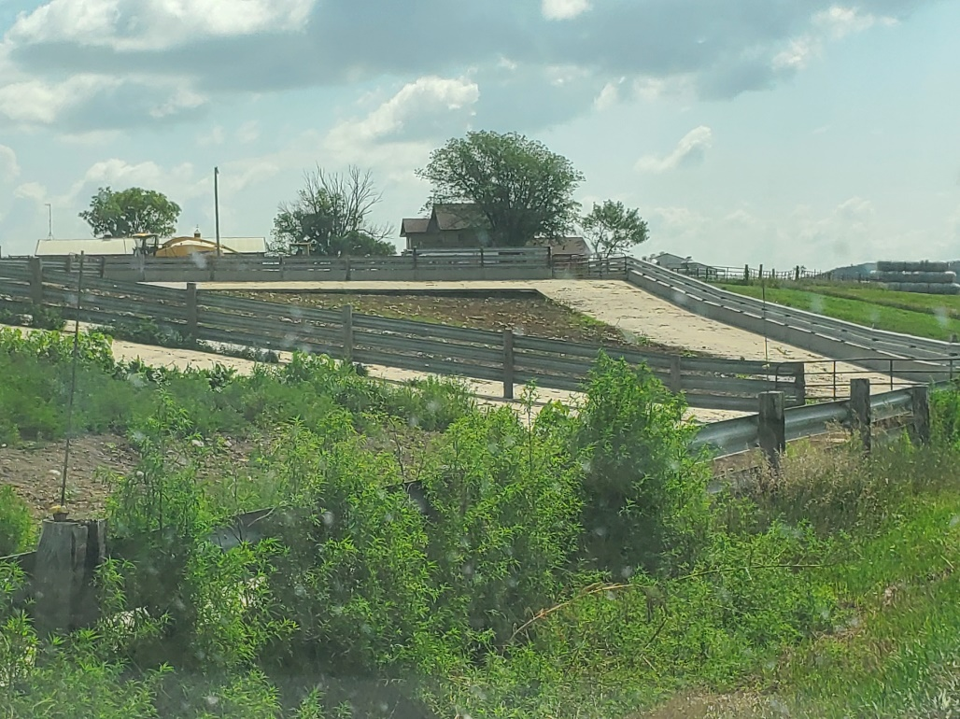 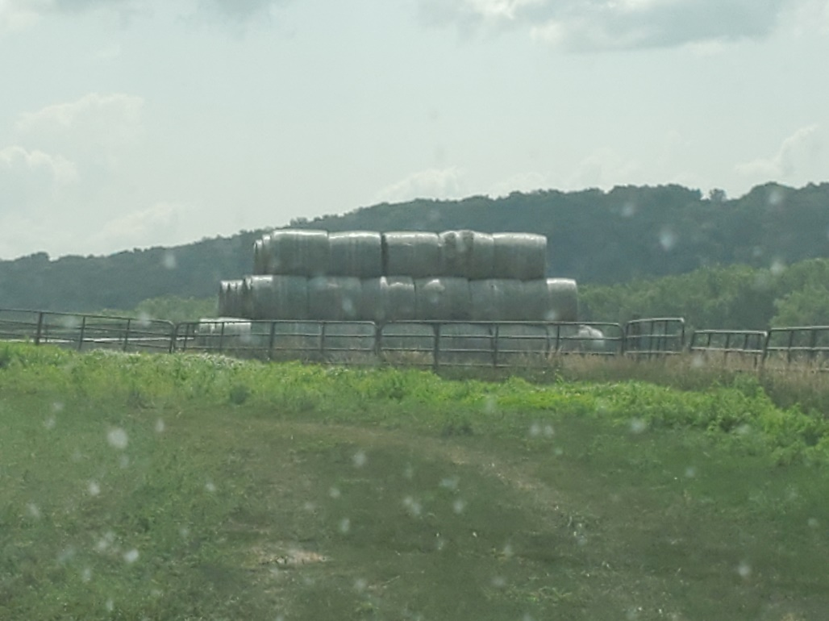Figure 9: View from west side of site looking eastward shows relief that is made use of Figure 10: Additional feed storage in southern-central portion of facility
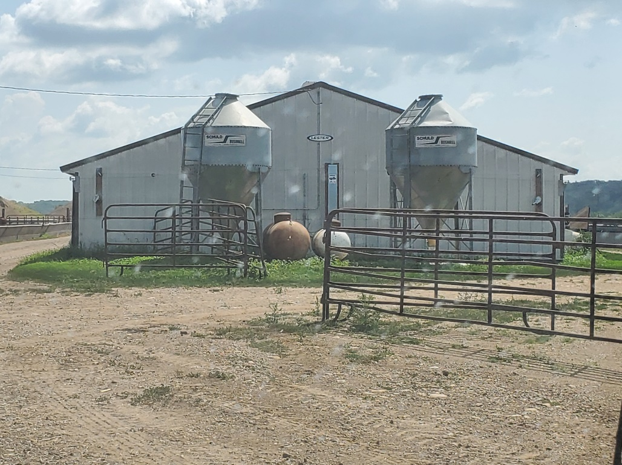 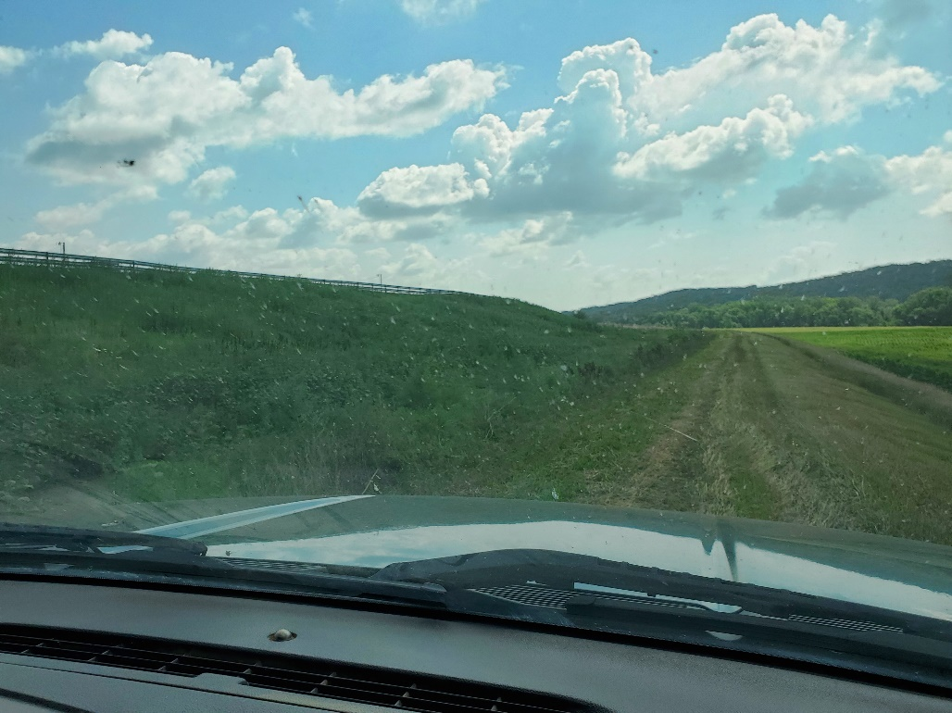Figure 11: Nursery confinement in southeast portion of facility Figure 12: Access drive at east end of facility shows relief that is utilized for drainage
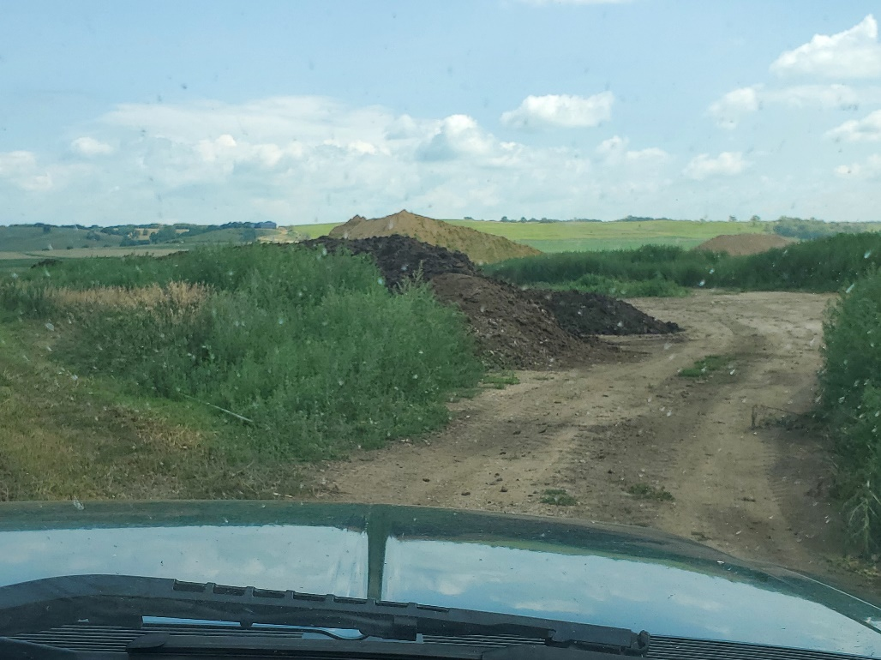 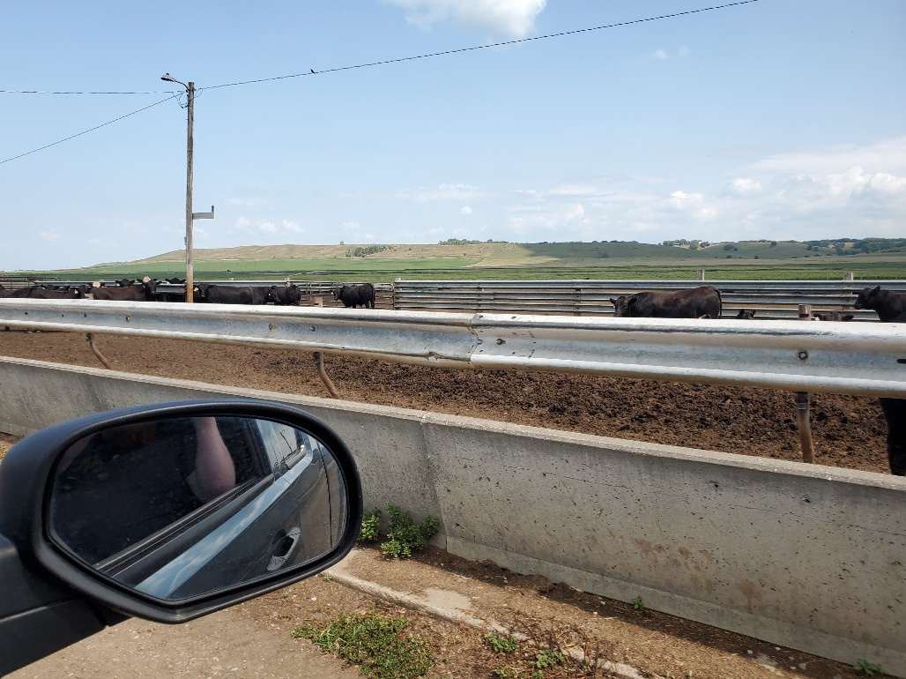Figure 13: Solid manure storage area at southeast end of facility, down-gradient from pens Figure 14: Well-maintained concrete barriers channel stormwater and effluent
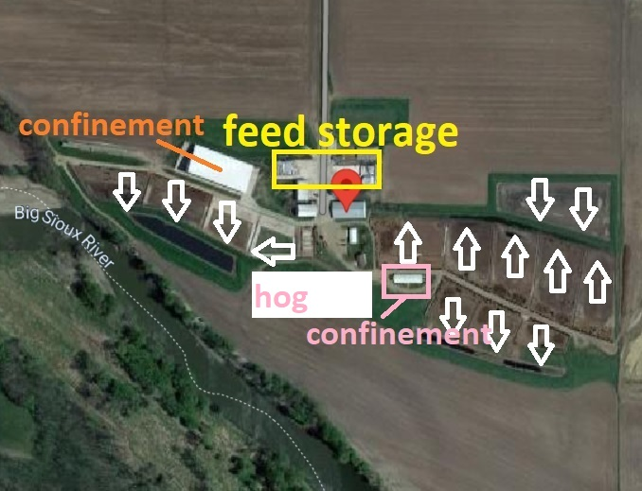 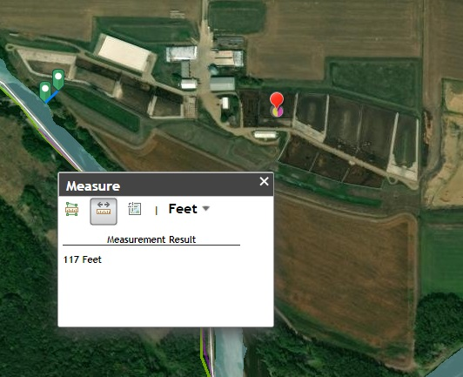Figure 15: Aerial view showing building locations and directions of effluent flow Figure 16: Erosion has brought river closer to facility since construction – now engineered

