MEMO

July 5, 2017

FACILITY NAME: Clinton County Municipal Solid Waste Landfill
FACILITY PERMIT NO: 23-SDP-01-74P
FACILITY ADDRESS: 4292 220th Street, Clinton, IA 52733 (P.O. Box 993)
FO6 DNR STAFF: Kurt Levetzow, ESS

On July 3, 2017, DNR Field Office 6 received a complaint as well as pictures of the Clinton County Landfill and what appeared to be lack of daily cover on the active working face. On July 3, 2017, at 4:30pm, Jim Kacer (DNR FO6 staff) and I arrived at the landfill for a complaint investigation. When we arrived, Brock Swan, contractor operator, was just leaving the property. We went to the front office, spoke with a female landfill employee in the office and asked for Brad Seward. Mr. Seward was not onsite. We explained that we needed to go up to see the working face, and the female employee granted us “permission”. Shortly after arriving at the working face, Mr. Swan drove up as he mentioned his front end loader had overheated and he was checking fluid levels. Mr. Kacer and I explained the reasoning of our visit and then we proceeded to the working face where took several photos of uncompacted and uncovered waste.

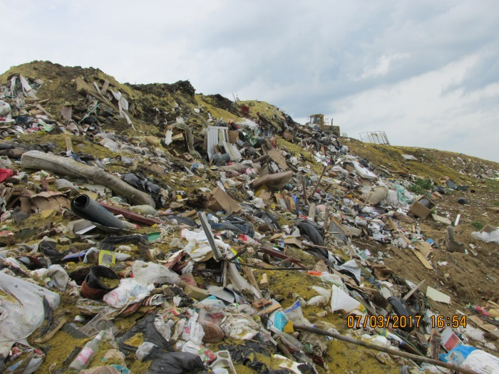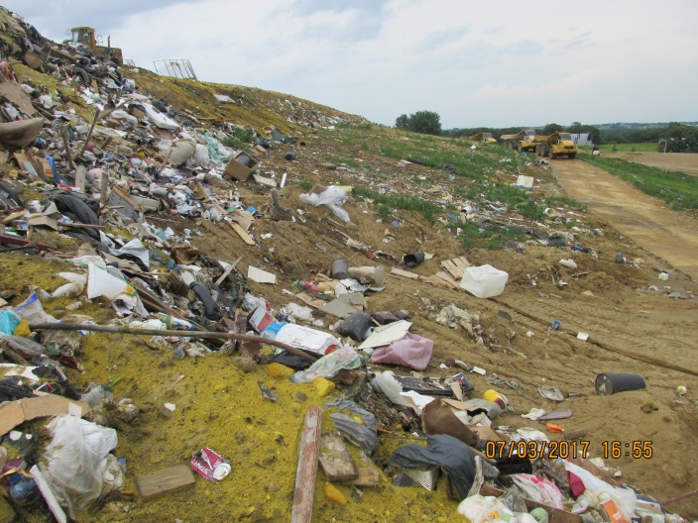
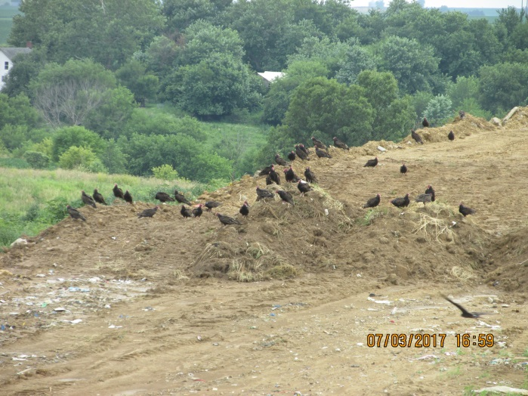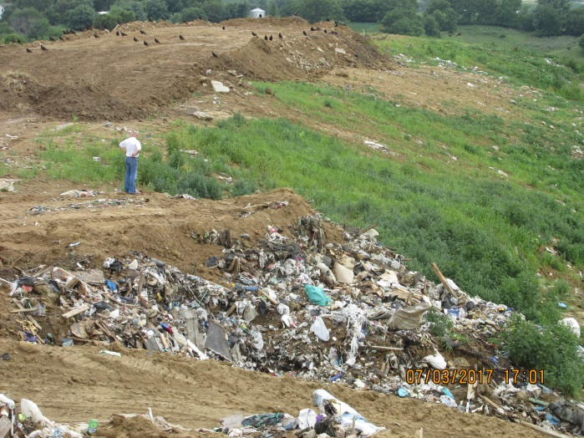

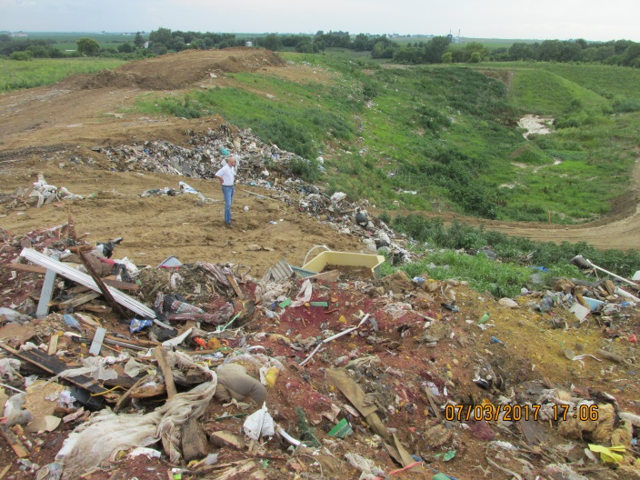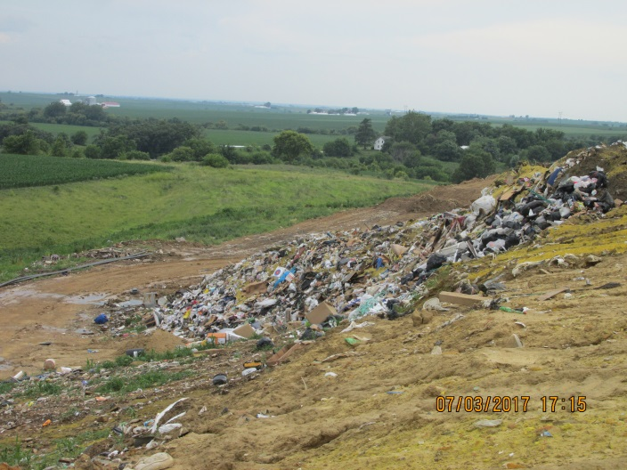

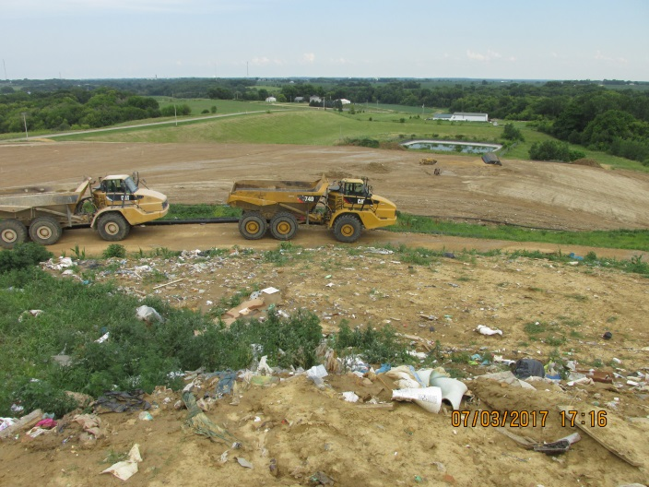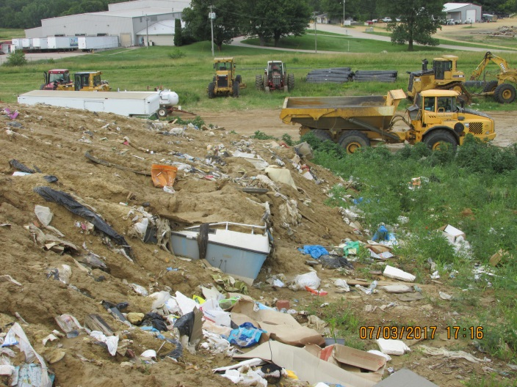
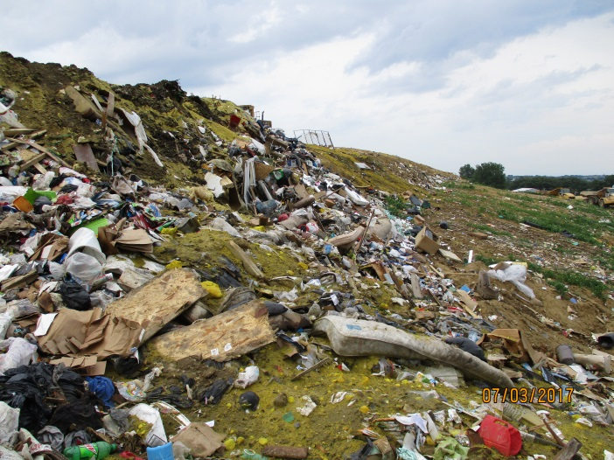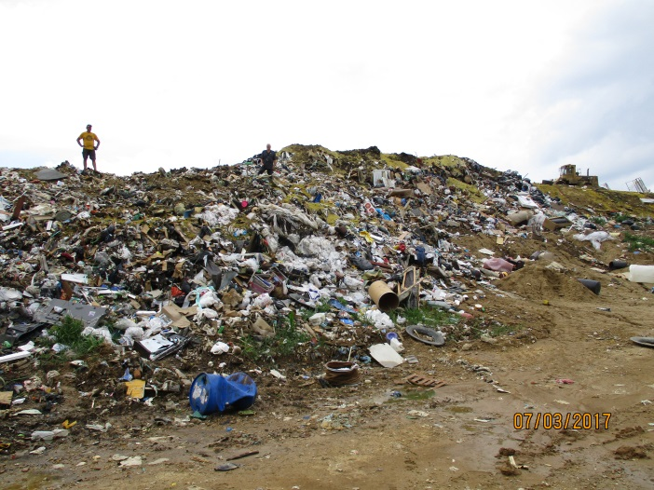

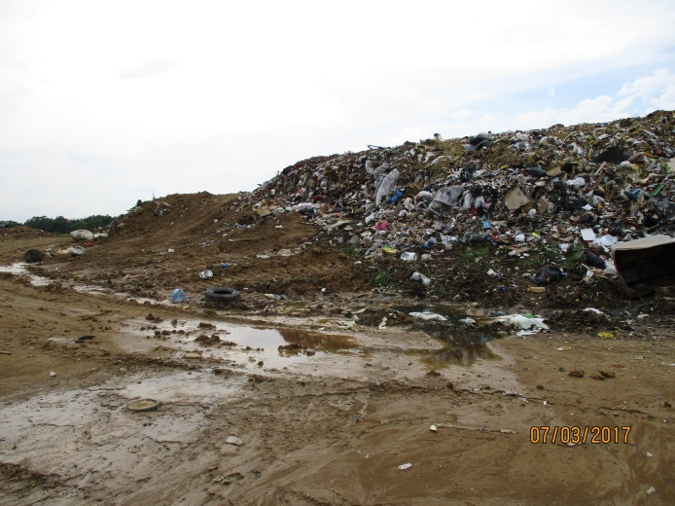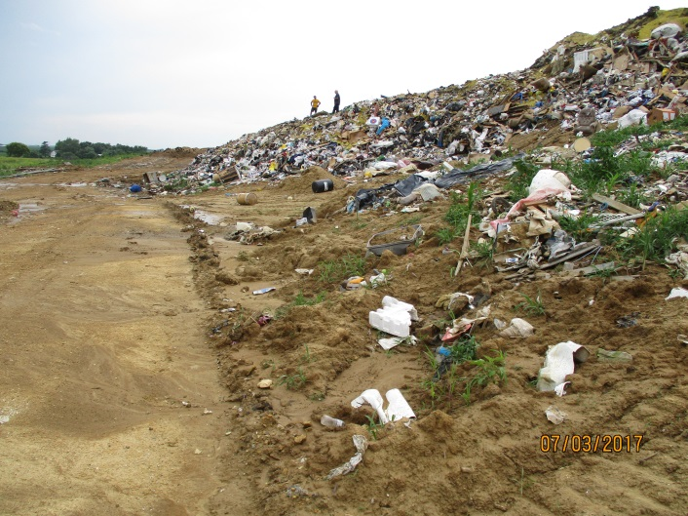

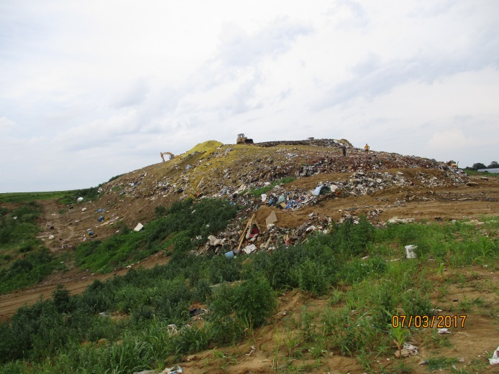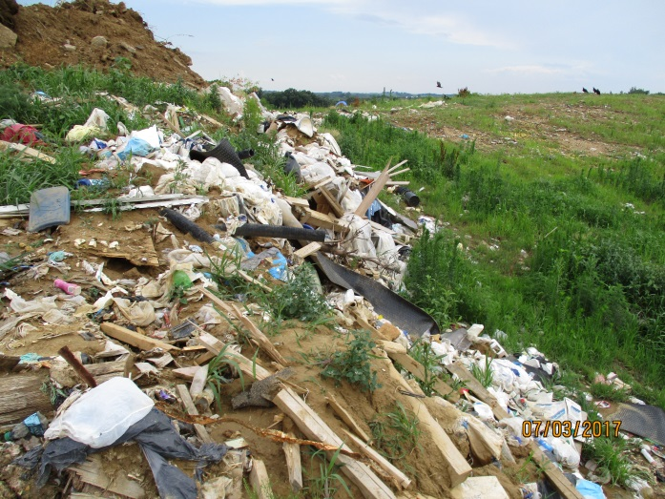
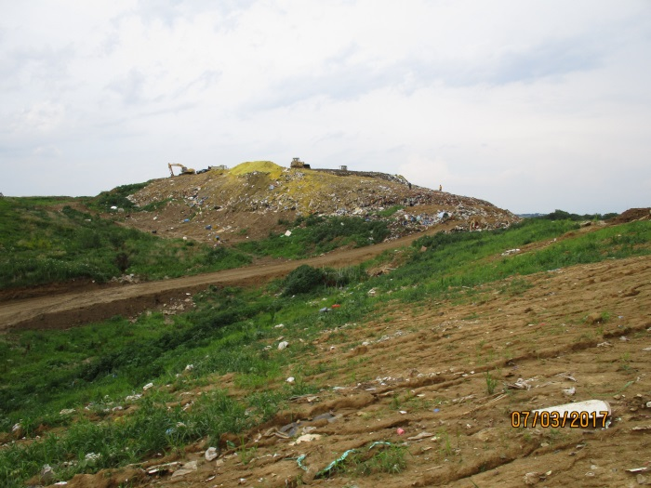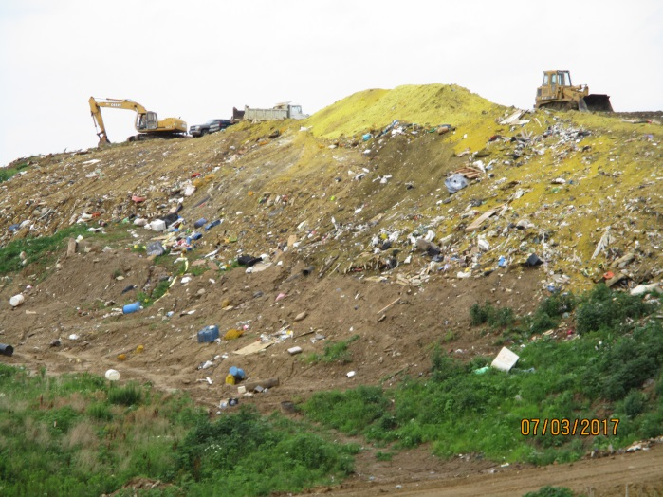

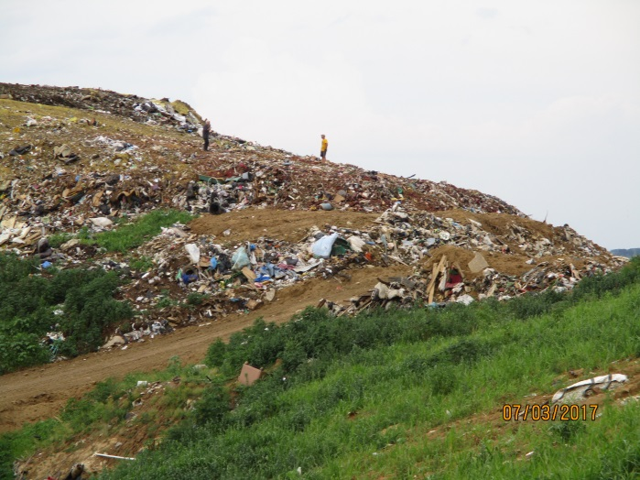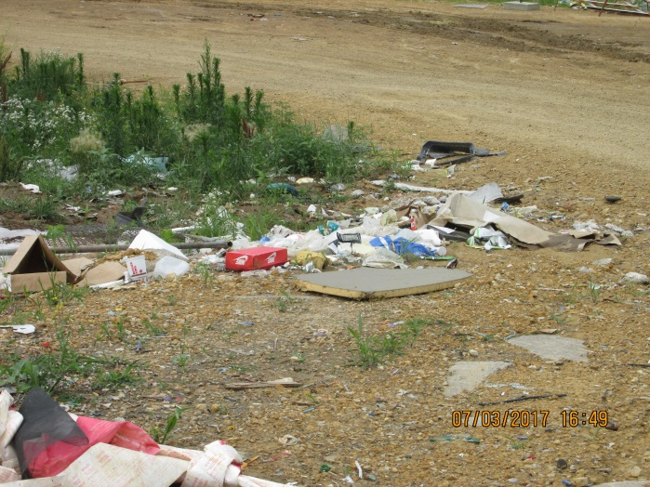

Development and Operations Plan contained in Appendix 5 of the 2015 Permit Renewal documentation, dated February 3, 2015 (in Doc 82424).

3.4.2 Steepness of Working Face
(2) The working face' shall not be so steep as to cause heavy equipment and solid waste collection vehicles to roll over or otherwise lose control. The slope of the working face will be maintained at a slope that will not cause heavy equipment and waste collection vehicles to roll over or otherwise lose control. Since a steel-wheeled compactor is used at the site, the working face will be constructed in flatter rather than steeper lifts. Flatter lifts generally allow a steel-wheeled compactor to travel faster, make more passes, and thereby achieve greater compaction with less work.

A notice of violation will be issued to the Clinton County Landfill for failure to comply with daily and intermediate cover requirements as well as failure to comply with daily litter control. This matter will be reviewed for referral to DNR Legal Services Bureau for further enforcement action.

N:klevetz/SW/SDP/2017/Clinton County Landfill cover memo 7-5-17.doc
Photo file: Clinton County Landfill 7-3-17 11-53.jpg & Clinton Co SLF 2017-07-03 1-38.jpg

