MEMO

DATE: November 2, 2021

TO: Chamness SDP File

FROM: Kurt Levetzow

On November 2, 2021, I conducted a site visit to Chamness Technologies to generally check out the facility operations, both the compost pad as well as the status of the leachate lagoons. Windrows have been developed over the past several weeks, which assists the flow of leachate offsite and into the east and west lagoons, whereas the middle lagoon is only used for additional storage. All three lagoons have little to no freeboard. The west lagoon appears to have overflowed, the east lagoon was actively overflowing and leachate was also observed flowing out of the derecho chipped wood pile (as leachate was pumped onto the derecho fire from this past summer).

Via text message on 11/2/21, I informed Richard Swan and Doug Maccrea, both with Chamness Technologies, of my observations and requested they start land applying leachate ASAP. Both Richard and Doug indicated it would start the morning of 11/3/21. As of 1134 hrs on 11/3/21, Doug informed me (via text) that he arrived onsite at 0850 hrs and by 0905 hrs the east lagoon was no longer running over. I responded and asked him when pumping began. Doug texted me on 11/3/21 and said pumping from the east lagoon had begun and that they’d be “strengthening” the berm that afternoon to prevent further leachate from seeping through.

Photos and explanation of my observations follow:

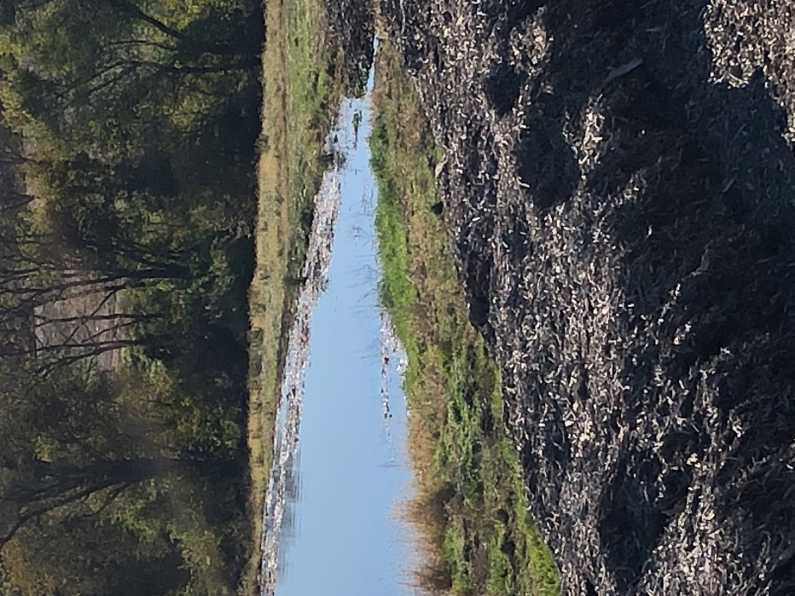
This photo was taken from the elevated location of the derecho pile, looking at the southern side of the east leachate lagoon. Observations suggest no freeboard.

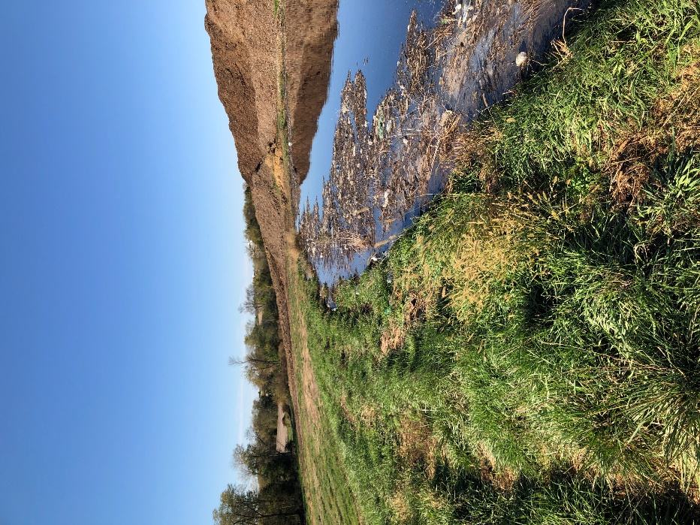
This photo was taken standing on the dike of the east lagoon looking to the west. Again, no freeboard is obvious in this photo.

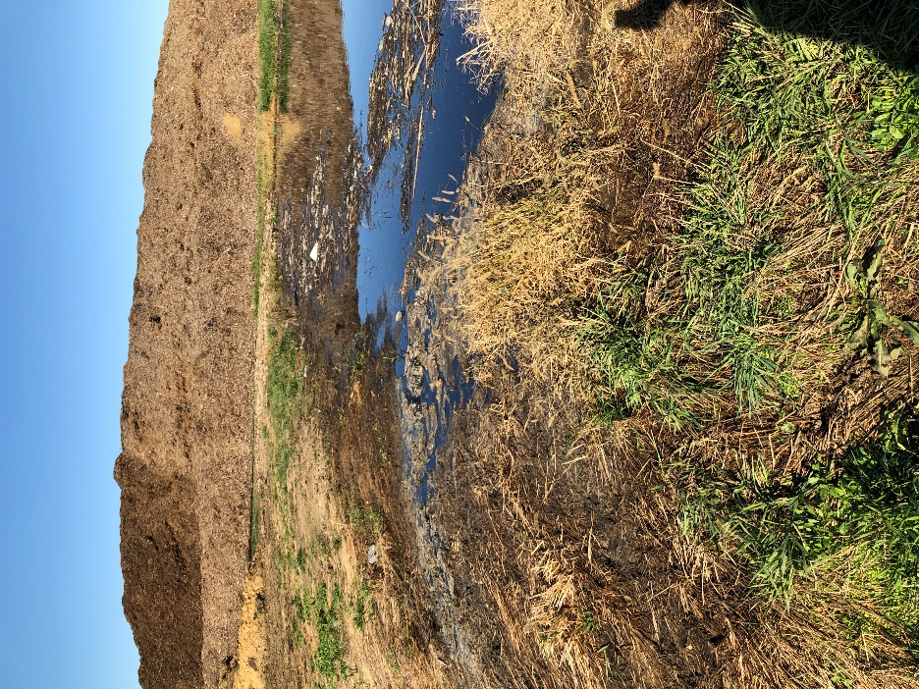
Still standing on the dike of the east leachate lagoon, with the derecho pile in the background. Leachate was flowing over the dike and downgradient toward Palestine Creek.
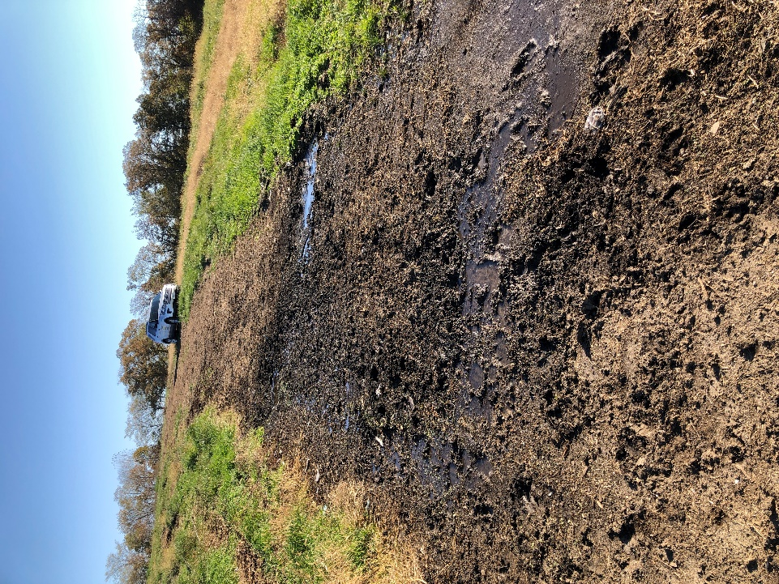
This photo is the road located between the east lagoon and Palestine Creek. See legend below.
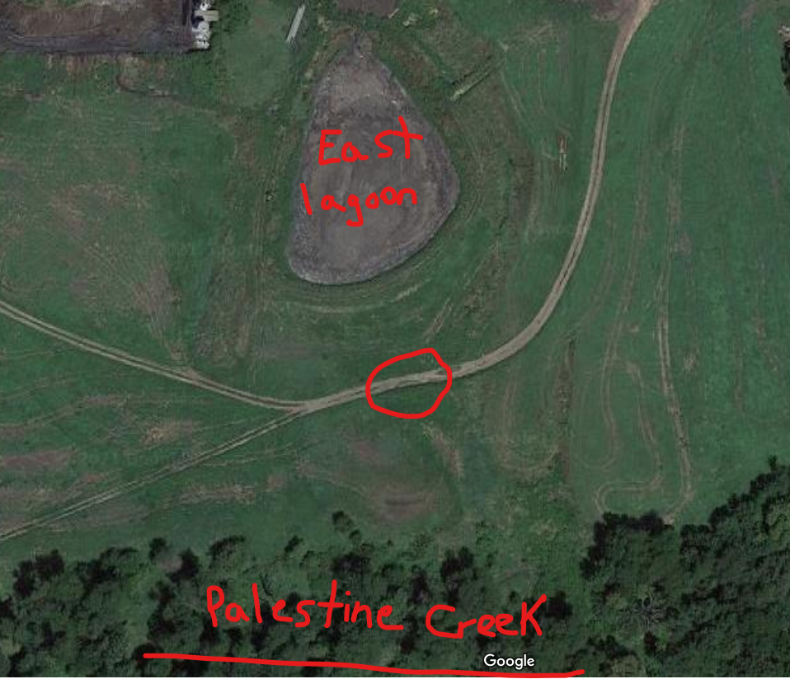
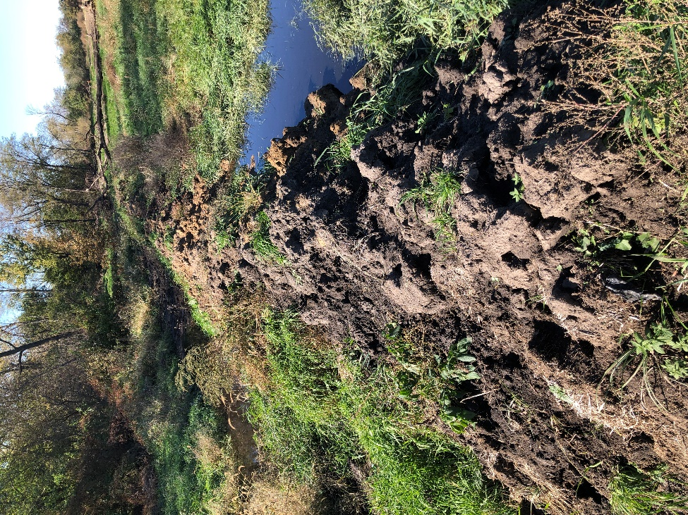

Pooled leachate south of the east lagoon. This little berm was constructed to keep leachate seeps from entering Palestine Creek, unfortunately, it didn’t work.
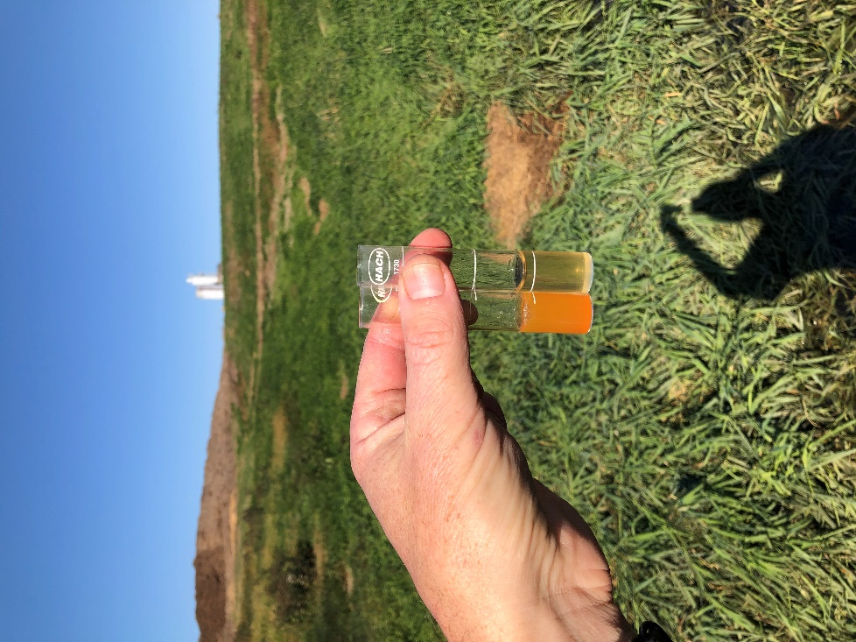
Field testing with ammonia kit in the bermed up leachate from the photo above. The orange indicates ammonia present in the leachate. This bermed area is just up gradient of Palestine Creek.
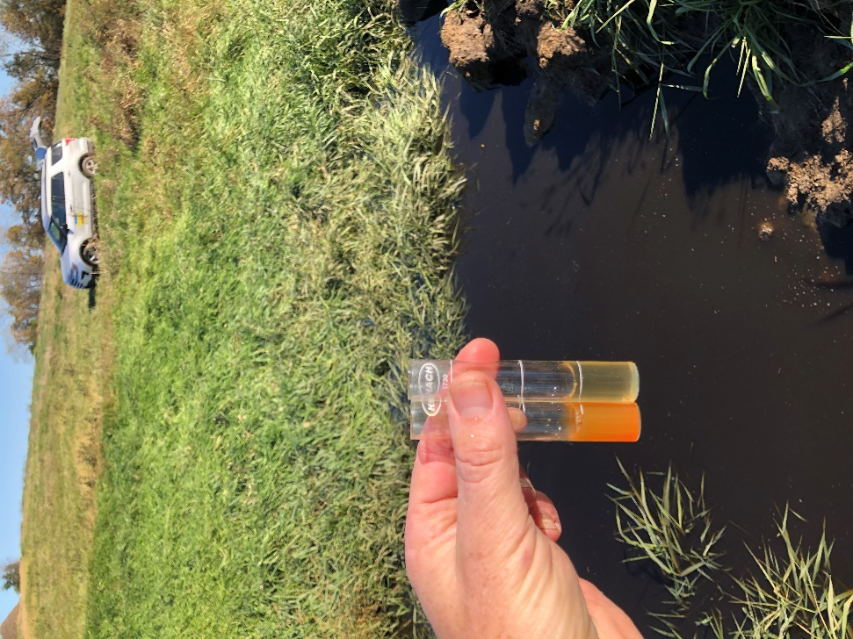
Another photo of the ammonia field test sampling in the bermed leachate just above Palestine Creek.
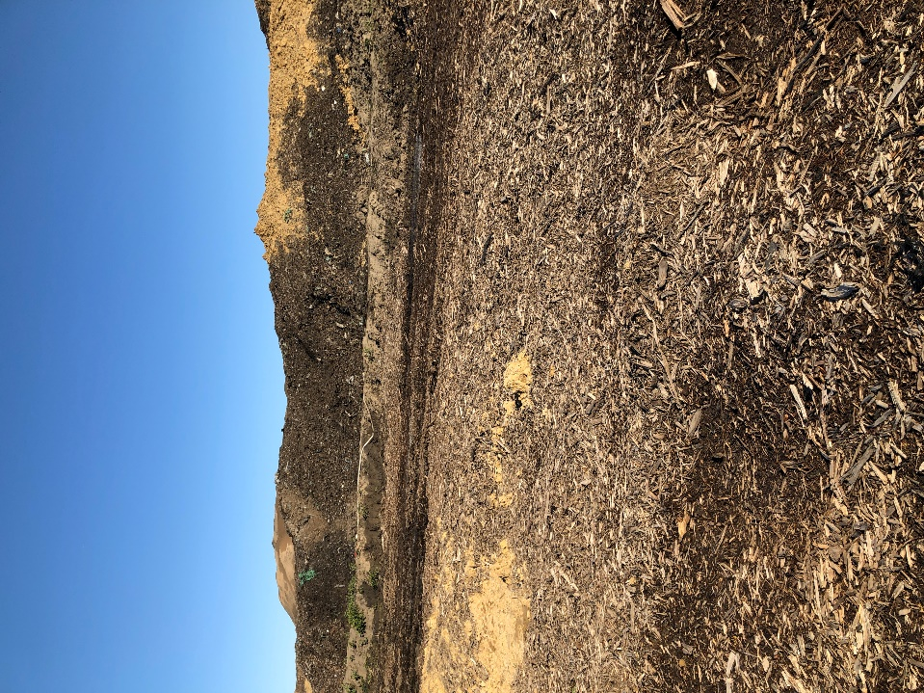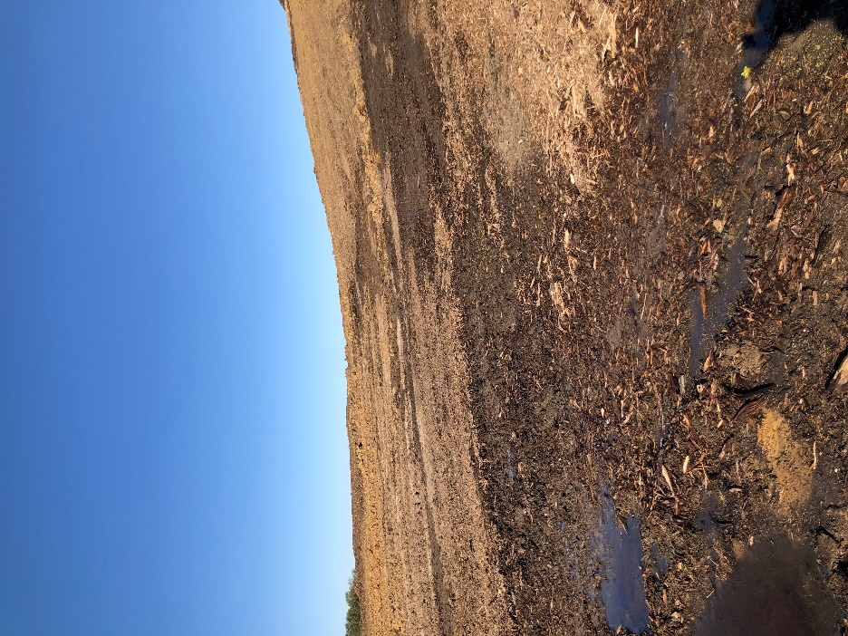

Leachate seeping out of the derecho pile, most certainly the result of using leachate to irrigate the fire that was consuming the derecho pile earlier in the summer.
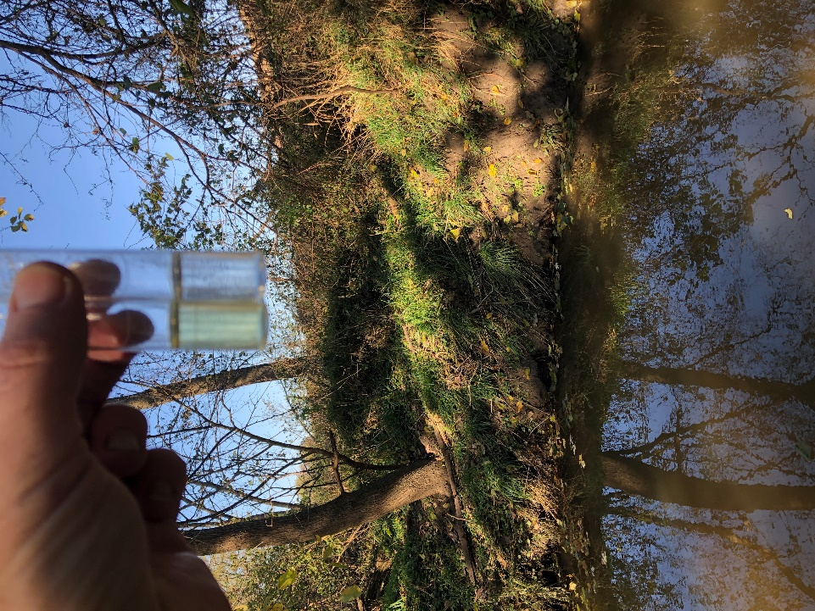
Ammonia testing above the confluence in Palestine Creek (upstream from where the leachate from the east lagoon was entering Palestine Creek).

xc:

