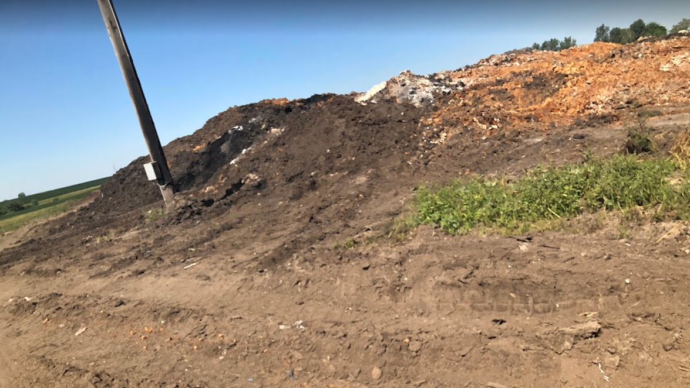
The above pict taken Friday August 21, 2020. Notice the telephone pole that was burned in the past. This is the area that DE (white) is mixed with the wet soap (brownish-red).

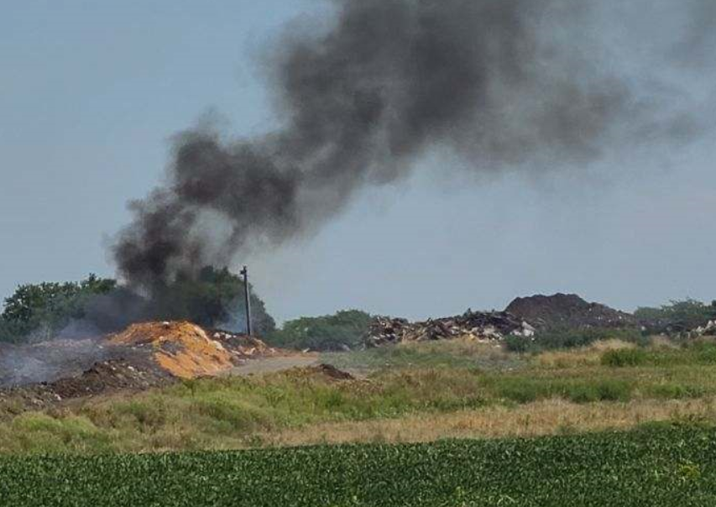
Notice the telephone pole.

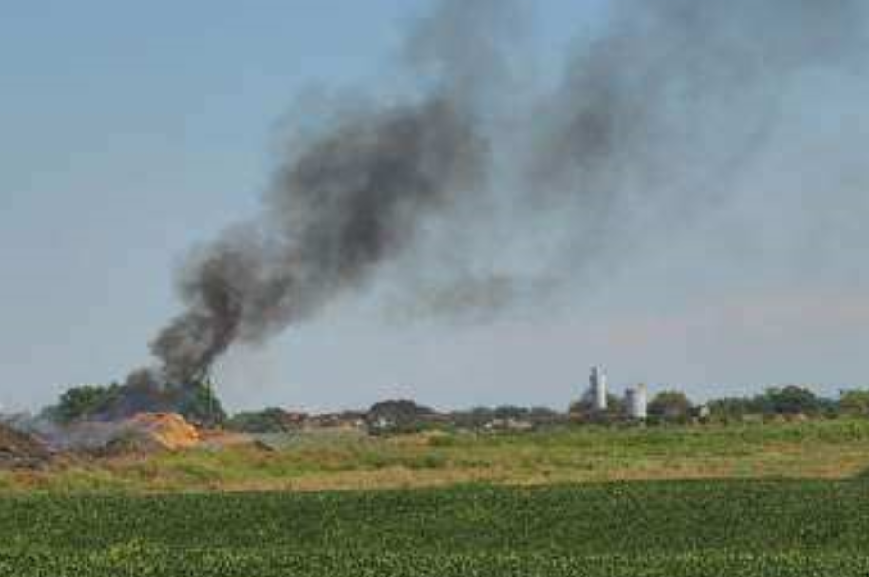
From the location of the telephone pole and the silos on the eastern side of the pad, it appears this fire was on the southwestern portion of the pad near where the DE is mixed with soap.

