October 17, 2020 Chamness Complaints – compost pile fire and smoke during a particularly windy day
 | Oct 17, 2020, 10:14 AM (2 days ago)
  Jacque Hough <jlhh1961@gmail.com>
to Kurt.levetzow@dnr.iowa.gov

I am writing to complain about Chamness and their lack of proper techniques in the composting business. They almost always are on fire and polluting our air in the Eddyville area. We live west of them an don’t smell it here as often as others do but no one should be experiencing the horrible air quality. Some of my family has asthma and are lucky we don’t live closer...we would have to move. They came into our neighborhood and are neglecting their duty to run the compost plant correctly. If any of us did this we would be fined and shut down.
Please shut them down!
Jacque Hough
1326 720th Ave Eddyville, Iowa 52553
--------------------------------------------------------------------------------------------------------------------

Chamness fire 10-17

 | Sat, Oct 17, 8:38 AM (2 days ago)
  Brea Lobberecht
to Kurt.Levetzow@dnr.iowa.gov

Chamness is on fire AGAIN and not a soul is there taking care of it. The smell is horrible and the whole town of Eddyville is engulfed in the disgusting smell of Chamness. The smoke is so thick you can barely see the road.
Someone needs to get this taken care of.
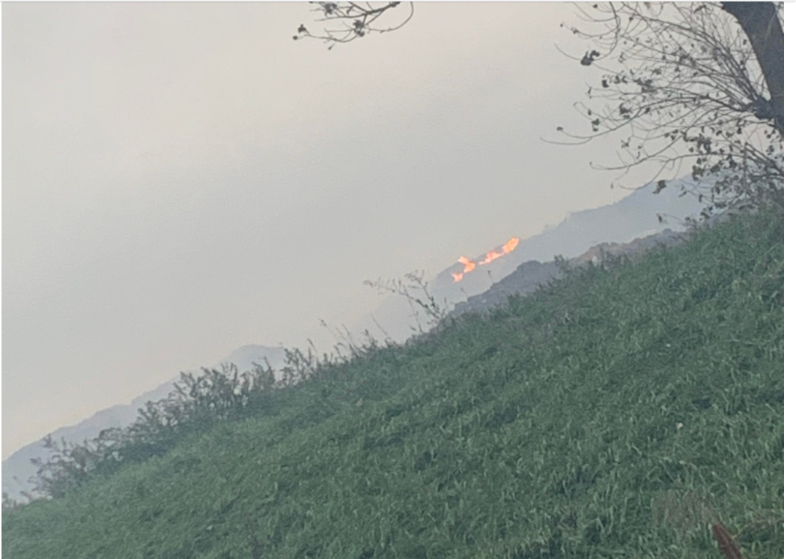

Compost plant
Inbox
 | 11:23 AM (25 minutes ago)
  Ray Fletcher <raysriverbend@yahoo.com>
to Kurt.levetzow@dnr.iowa.gov 10/19/20

Kurt, im sure you've been receiving plenty of complaints from other residents of Eddyville on the problem with Chamness.
Its time we shut them down. I had a splitting headache all weekend due to the fumes from it smoldering and we've had enough. Plus, my wife and I plan on selling our property in the next five years and this will hinder our property value. If there is a petition of any kind for this ,I'm on board.
Thank you
Ray Fletcher
Riverbend Longbows Outdoors
641-660-4198
-------------------------------------------------------------------------------------------------------------------------
Three other callers left me voice messages expressing their concerns of the smoke being a nuisance.

