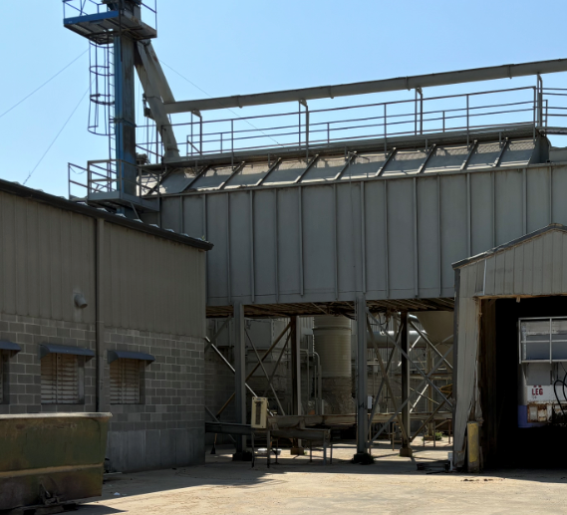
To IDNR.
August 29, 2024 area of note cleaned of sawdust. Two pictures.

Sawdust pile caused by a clogged pipe and resultant required maintenance on third (night) shift.

Bertch has hired a groundskeeper starting on September 9, 2024. This person is assigned specifically to the grounds maintenance of this dust collection area.

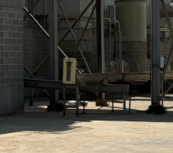
Masterbrand Engineers (6 people) are on Bertch site this whole week evaluating dust collection systems – preparing full report of recommended changes with priority projects for upper management’s consideration.

