September 14, 2021

DOUG HALL
1750 WEST 23RD ST
FREMONT, NE 60825

SUBJECT: APC-LLC Site (ID #61112), NW ¼, Section 6, Badger Township, Webster County

Dear Mr. Hall:

It has come to the attention of the Iowa Department of Natural Resources (DNR) that APC, LLC has purchased the above-referenced facility which was previously known to the Department as RSH Farms, Inc. This letter is in regard to DNR requirements applicable to this facility.

Manure Management Plan (MMP)
A new MMP was received on August 16, 2021. It has been administratively reviewed and was approved on August 26, 2021. MMP updates and fee payments are due annually by December 1. Every four years a complete MMP with updated Phosphorous Index information must be submitted.

Please be advised that you may now submit your MMP Short Form Annual Update via an electronic process at https://programs.iowadnr.gov/afoemmp/. Information regarding this process is enclosed.

Manure Applicator Certification & Application Records
Only a certified applicator, either a Commercial Manure Service (CMS) or a confinement site applicator, is allowed to apply manure from this facility. The facility owner is required by law to maintain detailed records of manure applications and any day-to-day changes made to the MMP. These records must include any changes to the plan, and all data on the actual manure application. Records must be maintained for five years, or for the length of the crop rotation following the year of manure application, whichever is greater.

If manure is applied to fields that are not owned or rented by the facility owner, a Statement of Intent from each crop producer indicating how much commercial N or P fertilizer will be applied to manured fields must be obtained, even if no commercial fertilizer will be applied. The signed statement must become part of the MMP and be kept with the MMP records. The forms needed to comply with the requirements can be printed from the internet at www.iowadnr.gov/Environmental-Protection/Animal-Feeding-Operations/AFO-Forms or picked up at the local DNR Field Office. Additional relevant information is available at www.iowadnr.gov/afo.

If you have any questions regarding this letter, please contact me at 641-424-4073.

Sincerely,

FIELD SERVICES AND COMPLIANCE BUREAU
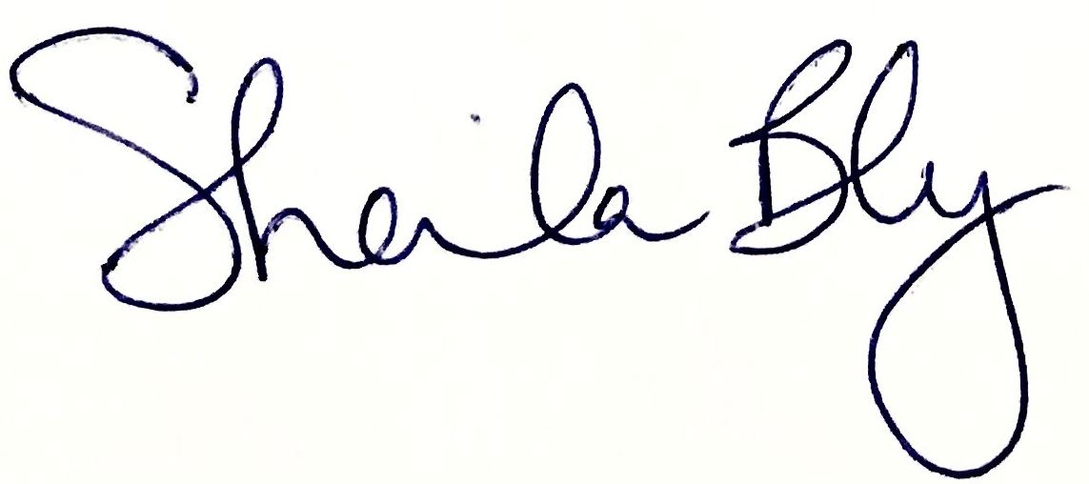
Sheila Bly, Environmental Specialist
sheila.bly@dnr.iowa.gov

Enc: PIN for Electronic MMP Short Form Submittal Process

